TEESSIDE UNIVERSITY
School of Computing, Engineering & Digital Technologies


DETECTION OF FRAUDULENT FINANCIAL TRANSACTIONS
USING DATA ANALYTICS AND MACHINE LEARNING

A Dissertation Submitted in Partial Fulfilment of the Requirements for the Degree of
MASTER OF SCIENCE IN DATA SCIENCE

Submitted by
Yaswanth Sai Tummala

Supervisor: Dr. Muhammad Zahid Iqbal
Module Name: Computing Masters Project
Module Code: CIS4055
Academic Year 2025-2026

Declaration
This dissertation is the original work of the author and has been written to satisfy the requirements of the Master of Science programme at Teesside University. All sources of information consulted during the preparation of this report have been formally acknowledged through in-text citations and the reference list at the end of this document. No part of this work has been submitted for any other degree, diploma or qualification at this or any other university. The dataset used for the analysis is publicly available and contains synthetic transaction records, which means no real customer information has been processed or stored at any stage of this project. The analytical notebook, the deployment code and the dashboard design are entirely the product of the author and have been built from scratch using only the open-source libraries cited in Chapter 7.

Signed: 
Date: 01 May 2026

Acknowledgement
The author wishes to acknowledge the support, guidance and patience of the academic supervisor Dr. Muhammad Zahid Iqbal at Teesside University, whose feedback shaped every chapter of this dissertation. Sincere thanks are also extended to the module leader of CIS4055 for providing a clear assessment framework and for explaining the difference between description and critical analysis during the early planning sessions. The technical staff at the campus computing labs deserve a separate mention for keeping the workstations available during the busy submission window.
Heartfelt appreciation goes to the open-source community that maintains the libraries used in this project. Without these well-tested tools, the timeline of this project would have stretched well beyond what a single master’s student can manage. The Kaggle community, where the synthetic financial fraud dataset was shared, made it possible to work on a realistic problem at a believable scale.
I am also grateful to my family and friends for their patience, encouragement and moral support throughout the project.

Abstract
Financial fraud is a fast-moving threat that costs the global economy billions of dollars every year. Card-not-present payments, mobile wallets and instant settlement schemes have widened the attack surface, while traditional rule-based systems have struggled to keep pace. This dissertation examines whether a combination of data analytics and machine learning can detect fraudulent transactions inside a large, imbalanced dataset of five million synthetic records. The study trains six classifiers (Logistic Regression, Decision Tree, Random Forest, XGBoost, K-Nearest Neighbours and Gradient Boosting), tunes their decision thresholds, and compares them across accuracy, precision, recall, F1 and ROC-AUC. The fraud rate in the dataset is just 3.59 percent, so the Synthetic Minority Oversampling Technique (SMOTE) is used to rebalance the training set. Twenty visualisations are produced during exploratory analysis, and the chosen model is wrapped inside a web application that exposes six interactive Power-BI-style dashboards together with a live-prediction page. The resulting deployment provides a practical end-to-end pipeline that fraud analysts can use, improving on the notebook-only workflow described in earlier studies. The findings confirm that ensemble methods produce the strongest detection performance and that engineered behavioural features (velocity, deviation, geo-anomaly) are far more informative than transaction amount alone. The dissertation ends with a discussion of practical limitations, a list of research gaps and a roadmap for future work, including streaming detection, explainable AI integration and graph-based modelling.
Keywords: financial fraud detection, machine learning, imbalanced classification, SMOTE, Random Forest, XGBoost, decision threshold tuning, interactive dashboards, web deployment, behavioural feature engineering.

List of Abbreviations
Table 1 lists every abbreviation used in this report together with its full expansion.
Acronym | Expansion
ACH | Automated Clearing House
API | Application Programming Interface
AUC | Area Under the Curve
ATM | Automated Teller Machine
CSV | Comma-Separated Values
CNN | Convolutional Neural Network
CPU | Central Processing Unit
DOI | Digital Object Identifier
EDA | Exploratory Data Analysis
ETL | Extract, Transform, Load
F1 | Harmonic Mean of Precision and Recall
FN | False Negative
FP | False Positive
GBM | Gradient Boosting Machine
IP | Internet Protocol
JSON | JavaScript Object Notation
KNN | K-Nearest Neighbours
LR | Logistic Regression
ML | Machine Learning
MLP | Multi-Layer Perceptron
POS | Point of Sale
RAM | Random Access Memory
RF | Random Forest
ROC | Receiver Operating Characteristic
SMOTE | Synthetic Minority Oversampling Technique
SQL | Structured Query Language
TN | True Negative
TP | True Positive
TPR | True Positive Rate
UI | User Interface
UPI | Unified Payments Interface
URL | Uniform Resource Locator
XGB | Extreme Gradient Boosting
Table 1: List of abbreviations used in this report

Table of Contents
Declaration 2
Acknowledgement 3
Abstract 4
List of Abbreviations 5
List of Figures 8
List of Tables 10
Chapter 1 — Introduction 11
1.1 Background 11
1.2 Aim of the Study 12
1.3 Research Objectives 12
1.4 Research Questions 13
1.5 Significance of the Study 13
1.6 Hypotheses 13
1.7 Scope and Limitations 14
1.8 Wider Fintech Context 14
1.9 Problem Statement 15
1.10 Ethical Considerations 15
1.11 Structure of the Dissertation 15
Chapter 2 — Literature Review 17
2.1 Overview 17
2.2 Traditional Rule-Based Detection 17
2.3 Statistical and Classical Machine Learning Approaches 17
2.4 Ensemble and Boosting Methods 18
2.5 Deep Learning and Neural Networks 19
2.6 Class Imbalance Strategies 19
2.7 Real-Time Streaming Detection 20
2.8 Graph-Based and Network Modelling 20
2.9 Federated and Privacy-Preserving Approaches 21
2.10 Explainability and Interpretability 21
2.11 Behavioural Biometrics 21
2.12 Hybrid Detection Schemes 22
2.13 Concept Drift Considerations 22
2.14 Comparative Summary Table 22
2.15 Research Gaps 23
Chapter 3 — Methodology 25
3.1 Research Design 25
3.2 Data Source and Description 25
3.3 Data Cleaning and Preprocessing 26
3.4 Feature Engineering 27
3.5 Algorithms Used 27
3.6 Imbalance Handling 28
3.7 Evaluation Metrics 28
3.8 Validation Strategy 29
3.9 Reproducibility 29
3.10 Deployment Architecture 30
3.11 Methodology Flow 30
3.12 System Architecture 31
3.13 Tools and Environment 31
Chapter 4 — Implementation 33
4.1 Environment Setup 33
4.2 Data Loading 33
4.3 Feature Engineering Walkthrough 33
4.4 Model Training Procedure 33
4.5 Threshold Tuning 34
4.6 Building the Web Application 34
4.7 Building the Six Dashboards 34
4.8 Live Prediction Page 35
4.9 Visual Identity and Theming 35
4.10 Typography and Accessibility 35
4.11 Performance Considerations 35
4.12 Input Validation and Error Handling 36
4.13 Design Rationale 36
4.14 Operational Behaviour 37
4.15 Security Hygiene 37
Chapter 5 — Results and Discussion 38
5.1 Dataset Statistics 38
5.2 Exploratory Findings 38
5.3 Model Comparison 41
5.4 Discussion of Best Model 43
5.5 Feature Importance 43
5.6 Behavioural Interpretation 44
5.7 Dashboard-by-Dashboard Findings 45
5.8 Cross-Dashboard Insights 46
5.9 Live Prediction Demonstration 46
5.10 Limitations of Results 47
Chapter 6 — Conclusion, Limitations and Future Work 48
6.1 Conclusion 48
6.2 Limitations 48
6.3 Future Recommendations 49
6.4 Practical Recommendations 49
Chapter 7 — References 51
Chapter 8 — Appendices 54
Appendix A — Notebook Section Index 54
Appendix B — Web Endpoint List 54
Appendix C — Dashboard URL Map 54
Appendix D — Sample Prediction Payload 55
Appendix E — Database Schema (excerpt) 55
Appendix F — Folder Structure of the Submission 56
Appendix G — Project Timeline 56
Appendix H — Deployment Screenshots 57

List of Figures
Figure | Title | Page
Figure 1 | Distribution of fraudulent versus legitimate transactions | 35
Figure 2 | Fraud counts by transaction type | 35
Figure 3 | Transaction amount distribution by class | 36
Figure 4 | Fraud counts by merchant category | 36
Figure 5 | Fraud counts by location (city) | 37
Figure 6 | Fraud counts by device used | 37
Figure 7 | Fraud counts by hour of day | 38
Figure 8 | Fraud counts by day of week | 38
Figure 9 | Monthly fraud trend | 39
Figure 10 | Correlation heatmap | 39
Figure 11 | Risk score analysis | 40
Figure 12 | Fraud counts by payment channel | 40
Figure 13 | Scatter of amount versus deviation score | 41
Figure 14 | Fraud rate per amount bucket | 41
Figure 15 | Weekday versus weekend fraud comparison | 42
Figure 16 | Merchant by device fraud-rate heatmap | 42
Figure 17 | Side-by-side model comparison | 43
Figure 18 | Confusion-matrix grid | 43
Figure 19 | ROC curves for all six models | 44
Figure 20 | Random-Forest feature importance | 44
Figure 21 | System architecture diagram | 24
Figure 22 | Methodology pipeline flow | 24
Figure 23 | Deployment home page | 54
Figure 24 | Live prediction page (form) | 54
Figure 25 | Live prediction result (suspicious) | 55
Figure 26 | Live prediction result (legitimate) | 55
Figure 27 | Dashboard 1 — Fraud Overview | 56
Figure 28 | Dashboard 2 — Transaction Patterns | 56
Figure 29 | Dashboard 3 — Geography & Devices | 57
Figure 30 | Dashboard 4 — Time-Series & Trends | 57
Figure 31 | Dashboard 5 — Risk Score Analysis | 58
Figure 32 | Dashboard 6 — Model Performance | 58
Figure 33 | Confusion matrix on dashboard | 59
Figure 34 | ROC curves on dashboard | 59
Figure 35 | Feature importance on dashboard | 60
Figure 36 | Risk band breakdown | 60
Figure 37 | KPI cards | 61
Figure 38 | 404 error page | 61
Figure 39 | Aggregations data view | 62
Figure 40 | Database schema diagram | 62
Figure 41 | Notebook EDA snapshot | 63
Figure 42 | Notebook model evaluation snapshot | 63

List of Tables
Table | Title | Page
Table 1 | List of abbreviations | v
Table 2 | Comparative summary of recent fraud-detection studies | 15
Table 3 | Identified research gaps | 16
Table 4 | Dataset attributes and meaning | 18
Table 5 | Engineered features added during preprocessing | 19
Table 6 | Hyper-parameters of the six trained models | 20
Table 7 | Confusion-matrix structure | 21
Table 8 | Tools and software stack | 25
Table 9 | Headline statistics of the full dataset | 34
Table 10 | Class balance after SMOTE oversampling | 34
Table 11 | Model performance comparison | 37
Table 12 | Top fraud-rate merchant categories | 40
Table 13 | Top ten features by importance | 39
Table 14 | Project timeline summary | 53
Table 15 | Notebook section index | 49
Table 16 | Web endpoint list | 49
Table 17 | Dashboard URL map | 50

Chapter 1 — Introduction

1.1 Background
Digital payments have replaced cash for many everyday transactions in the past decade. According to the Bank of England payment statistics, more than nine out of ten retail payments in the United Kingdom now flow through cards, online banking apps or instant payment rails. The same convenience that lets a shopper pay for groceries with a tap also opens the door for criminals to steal money at machine speed. Industry associations such as UK Finance estimate that unauthorised fraud and authorised push-payment scams together caused losses worth over GBP 1.2 billion in 2023 alone. The Federal Trade Commission in the United States and the European Banking Authority report similar growth curves [1, 4].
Banks were the first organisations to invest in automated fraud detection systems, but most of those systems still rely on hand-written rules, for example flagging any transaction above a fixed threshold or any payment made from an unfamiliar country. Rule-based systems are easy to explain to auditors; however they are slow to update and they generate large numbers of false alarms [2, 3]. Machine learning offers a different approach: instead of telling the computer exactly which transactions look suspicious, the data scientist supplies labelled examples and lets the model learn patterns by itself. This data-driven approach has been shown to capture subtle behavioural signals that no rule writer would think to encode by hand [5, 9].
The regulatory landscape has also shifted. The revised Payment Services Directive (PSD2) in Europe requires Strong Customer Authentication for most online card transactions, and the Digital Operational Resilience Act (DORA) demands that financial institutions demonstrate the robustness of their detection systems against operational and cyber risks. The Financial Conduct Authority in the United Kingdom has published guidance that calls for explainable, well-monitored machine-learning models in customer-facing decisions. These developments mean that a modern fraud-detection pipeline must do more than maximise a single accuracy figure; it must be reproducible, auditable, and capable of being inspected by a human reviewer when an outcome is challenged.
Globally, the picture is similar. The Association of Certified Fraud Examiners reports that organisations lose roughly five percent of annual revenue to occupational fraud, with median losses concentrated in financial services and retail. In the Asia-Pacific region, the rapid adoption of unified payment interfaces and quick-response code wallets has produced new fraud vectors built around social engineering rather than card cloning, with money mules and remote-access scams replacing the older skimmer-based attacks. The breadth and adaptability of contemporary fraud underline why a combination of data analytics and supervised learning is now the recommended technical foundation for modern detection programmes.

1.2 Aim of the Study
The overall aim of this dissertation is to build, evaluate and deploy a machine-learning pipeline that can detect fraudulent financial transactions at high recall while keeping the false-alarm rate manageable. The pipeline must be reproducible end to end, must work on a realistic five-million-row dataset, and must be exposed through a professional web interface so that an analyst with no programming knowledge can interact with the results. A second, equally important aim is to demonstrate the methodological discipline expected of a postgraduate data-science project, namely careful data partitioning, transparent handling of class imbalance, comparative model evaluation, and the production of artefacts that another researcher could rerun on a different machine.

1.3 Research Objectives
- To analyse the financial fraud dataset and identify the variables that best discriminate between fraudulent and legitimate transactions.
- To engineer additional behavioural features such as velocity flags, deviation flags and geographic anomaly flags that capture meaningful risk signals.
- To handle the class-imbalance problem using the SMOTE oversampling technique on the training partition only.
- To train six well-known machine-learning classifiers and tune their decision thresholds for the F1-score under identical experimental conditions.
- To evaluate the trained models using accuracy, precision, recall, F1 and ROC-AUC, and to select the best performing model for deployment.
- To build a web application that hosts six interactive Power-BI-style dashboards plus a live-prediction page that an analyst with no programming knowledge can use.
- To document every step of the work in a dissertation that follows the standard university structure and that can be replicated by another researcher.

1.4 Research Questions
- Which variables in the financial transaction dataset are the strongest predictors of fraud?
- Does SMOTE oversampling lead to a measurable improvement in recall on an imbalanced dataset?
- Which of the six tested classifiers delivers the best F1-score after decision threshold tuning?
- How can the trained model be deployed in a way that non-technical users can interact with the predictions?
- What additional steps would be needed to bring the prototype deployment closer to a production-grade fraud-detection system?

1.5 Significance of the Study
The significance of this work is threefold. From an academic standpoint, the dissertation contributes a side-by-side comparison of six classifiers on a five-million-row dataset, accompanied by careful threshold tuning and SMOTE balancing. Earlier studies often used much smaller samples or reported only a single accuracy figure [10, 13]. From a practical standpoint, the deployment produced alongside the report shows that a usable fraud dashboard can be built without expensive commercial software, using only open-source tools. From a societal standpoint, even small accuracy gains on the recall side of a fraud detector translate to large reductions in real-world financial losses for individual consumers, particularly the elderly and other vulnerable groups who are disproportionately targeted by authorised push-payment scams. By framing the model as a decision-support tool that produces a probability score and a list of contributing flags rather than an automated blocker, the project also follows the human-in-the-loop philosophy advocated by industry regulators.

1.6 Hypotheses
This dissertation tests four working hypotheses:
- H1: Ensemble tree-based methods (Random Forest, XGBoost, Gradient Boosting) outperform single-tree and linear models on the F1 metric.
- H2: SMOTE oversampling raises recall by more than ten percentage points compared with training on the raw imbalanced data.
- H3: Engineered behavioural features (velocity score, deviation score, geo-anomaly score) carry higher importance values than the raw transaction amount in a Random Forest importance ranking.
- H4: A tuned probability threshold below 0.5 is needed to maximise the F1-score on a dataset whose fraud rate is below five percent.

1.7 Scope and Limitations
The scope of the dissertation is limited to the supervised-learning problem of binary classification (fraud / not fraud). Unsupervised anomaly detection methods such as Isolation Forest or Autoencoders are discussed in the literature review but are not implemented. The dataset used is synthetic, so behavioural artefacts that show up in production data (for example coordinated attacks across multiple cards, slow-moving money-laundering chains and account-takeover sequences) are not present in the experimental sample. The web deployment is configured for a local single-machine demonstration only; a production deployment would require additional layers such as authentication, request throttling, transport security and observability. These boundaries are stated explicitly so that the conclusions of Chapter 6 can be read in the correct context.

1.8 Wider Fintech Context
The wider financial-technology context provides additional motivation for this study. Open-banking application programming interfaces now allow third-party providers to initiate payments and read account information on behalf of customers, which has expanded the attack surface beyond the traditional cardholder-merchant relationship. Real-time gross settlement schemes such as the Single Euro Payments Area instant credit transfer scheme settle in under ten seconds, leaving little time for a human reviewer to intervene before money leaves the originating account. The combination of broader access and shorter settlement windows means that the only realistic line of defence at the moment of payment is an automated detection model that returns a verdict in milliseconds. Any methodology that hopes to be relevant to the next decade of fraud-detection research must therefore demonstrate not only strong offline metrics but also a deployment pattern that can run inside a request-response loop without human assistance.

1.9 Problem Statement
The problem addressed by this dissertation can be stated in one sentence: given a stream of financial transactions, design a detection system that flags the small minority of fraudulent records with high recall while keeping false alarms manageable, and that exposes its decisions through a transparent interface so that a human analyst can investigate any flagged case efficiently. Although the sentence is simple, the underlying engineering touches on data preparation, supervised learning, imbalance handling, threshold calibration, software architecture and human-computer interaction. The breadth of disciplines required is the main reason why the comparative literature shows such varied performance figures, and it is the main reason why a single integrated study with a working deployment is more useful than another tuned-classifier benchmark.

1.10 Ethical Considerations
Although the dataset is synthetic, the ethical position of an automated fraud detector is worth stating explicitly. Any system that flags transactions can also block legitimate purchases by mistake, which causes inconvenience and embarrassment to the customer. The model trained in this work is therefore framed as a decision-support tool that produces a probability score and a list of contributing flags, not as a fully automated blocker. A human analyst remains in the loop, which is the standard recommendation in the regulatory literature on financial machine learning [4, 9]. No personal data is stored or transmitted by the backend, and the demonstration runs only on the local machine of the developer. Where the dashboards display location names or merchant categories, those values are taken directly from the synthetic dataset and do not represent real customers, businesses or addresses.

1.11 Structure of the Dissertation
The remainder of this report is organised as follows. Chapter 2 reviews the literature on financial fraud detection, with an emphasis on studies published between 2018 and 2024 and ends with a comparative summary table and an explicit list of research gaps. Chapter 3 describes the methodology, including the architecture of the deployment, the algorithms used and the evaluation strategy. Chapter 4 walks through the actual implementation and explains the design decisions taken at every stage of the pipeline. Chapter 5 reports the results, presents the exploratory visualisations and discusses the operational implications of each dashboard. Chapter 6 summarises the conclusions, acknowledges the limitations and proposes future work. Chapter 7 lists the references with working DOI links, and Chapter 8 contains the appendices, including representative code snippets, the database schema and screenshots from the deployment.

Chapter 2 — Literature Review

2.1 Overview
This chapter reviews the academic and industry literature on financial fraud detection. The review concentrates on studies published between 2018 and 2024 because earlier work tends to deal with small datasets and with simpler statistical models that have largely been replaced by modern ensemble and deep-learning approaches. The chapter is organised by methodological family, beginning with rule-based systems and ending with research gaps that the present dissertation tries to address. Wherever possible the discussion connects each method back to the operational priorities of a real fraud-detection programme, namely high recall on confirmed fraud, manageable analyst workload, and the ability to explain a decision to a regulator.

2.2 Traditional Rule-Based Detection
Rule-based systems use a set of expert-written conditions to mark suspicious transactions, for instance any payment over a fixed currency value made outside the cardholder home country. Hilal et al. [4] explain that such systems remain in use because they are easy to audit, yet they are brittle because every new attack pattern requires a manual rule update. Cherif et al. [3] show that rule-based detectors typically produce false-alarm rates of more than ten percent, which translates to a large operational cost for the human analyst team responsible for reviewing each alert. The same authors note that rule-based systems cannot capture interaction effects between attributes, such as the combination of an unusual merchant category with a brand-new device.
A second drawback of rule engines is the cold-start problem associated with new payment products. When a bank launches a new instant-payment rail or a new mobile wallet, the historical fraud patterns that informed the existing rules no longer apply, and the engineering team must rewrite a large block of rules from scratch. Machine-learning detectors, by contrast, can be retrained on a few weeks of fresh transactions and adapt to the new product without explicit human intervention, although the cold-start period during which there are too few labelled examples remains a research challenge.

2.3 Statistical and Classical Machine Learning Approaches
The earliest machine-learning replacements for rule engines were Logistic Regression and Naive Bayes classifiers. Awoyemi et al. [12] benchmarked these methods on a publicly available European card dataset and reported recall values between 0.55 and 0.70. Dornadula and Geetha [6] extended the benchmark with Decision Trees and K-Nearest Neighbours, observing that recall improved when the classifier was given engineered behavioural features rather than raw monetary amounts.
Pumsirirat and Yan [14] applied a Restricted Boltzmann Machine on a similar dataset and reported an F1-score of 0.60 after class balancing. Their study highlighted the interaction between resampling and the choice of classifier - a point that is revisited in Section 2.6 of this chapter. Ileberi et al. [11] proposed a genetic algorithm for feature selection that fed into a Logistic Regression baseline; the authors reported an AUC of 0.94 on a 280K-row dataset, showing that careful feature engineering can lift simple linear models to competitive performance levels.
A common thread across the classical-machine-learning literature is the observation that the headline metric is highly sensitive to the random partitioning of the dataset. Several studies report ten-fold cross-validation results, while others report a single hold-out partition, which makes side-by-side comparison difficult. The present dissertation uses a single train-test partition for clarity but acknowledges that a multi-fold evaluation would be more rigorous. The trade-off between rigour and computational cost on a five-million-row dataset is discussed in Chapter 3.

2.4 Ensemble and Boosting Methods
Random Forest, introduced by Breiman [16], remains one of the most reliable classifiers for tabular fraud problems. Forough and Momtazi [8] compared seven classifiers and found that Random Forest produced the second-best F1-score after a stacked ensemble. XGBoost, the scalable gradient-boosting library by Chen and Guestrin [17], has largely replaced Random Forest in industry practice because of its native support for missing values and its smaller model size. Esenogho et al. [21] reported that XGBoost combined with feature engineering reached an F1 of 0.87 on the European card dataset, beating both single trees and Logistic Regression by a wide margin.
Alarfaj et al. [9] reviewed twelve recent fraud-detection studies and observed that gradient-boosting variants consistently appeared in the top three of every benchmark. The authors also highlighted that no single classifier dominates across all metrics; some boost models trade recall for precision, which means the choice of best model depends on the operational priorities of the financial institution. A recurring observation across the ensemble literature is that hyper-parameter tuning yields smaller gains than feature engineering once the model has reached the gradient-boosting tier. This is consistent with the well-known machine-learning aphorism that more and better features outperform more and better algorithms, and it strongly motivates the feature-engineering programme described in Chapter 3.

2.5 Deep Learning and Neural Networks
Deep neural networks have been applied to fraud detection both as supervised classifiers and as autoencoders for unsupervised anomaly scoring. Roy et al. [13] trained a feed-forward Multi-Layer Perceptron and reported an AUC of 0.91 on a Capital One dataset. Lucas et al. [2] introduced a Hidden Markov Model with multi-perspective features for sequential fraud detection on a card stream, demonstrating that temporal context improves detection by approximately five percentage points compared with a non-sequential baseline.
More recent work by Asha and Kumar [15] used a fully connected neural network on the European credit-card dataset and obtained a recall of 0.84. Nguyen et al. [18] surveyed deep-learning fraud detection and flagged two practical issues: the long training time on CPU-only environments and the lack of model interpretability. The latter is considered a major adoption barrier inside regulated financial firms, where a model that cannot be explained in plain language is unlikely to pass internal model-risk review even if its headline F1-score is impressive.
A small but growing body of work explores transformer-based sequence models for fraud, treating each customer recent transactions as a tokenised sequence. The early results are competitive with gradient-boosting baselines on streaming benchmarks, but the training cost rises steeply with the length of the customer history, and the operational benefit over a well-engineered tabular baseline is still being debated.

2.6 Class Imbalance Strategies
Because fraud usually accounts for less than five percent of transactions, the imbalance problem is central to every published study. Three families of solutions are reported in the literature: cost-sensitive learning, undersampling and oversampling. Chawla et al. [20] introduced SMOTE, a now-classic technique that creates synthetic minority points along the line segments between existing minority-class neighbours. Singh et al. [7] compared SMOTE, ADASYN and random undersampling on a card-fraud problem and concluded that SMOTE produced the most stable F1-scores, although the technique can introduce noise when the minority class itself is heterogeneous.
Carcillo et al. [1] proposed a hybrid scheme that combines unsupervised anomaly scores with supervised classifiers, reporting that the hybrid approach lifts precision-recall AUC by about six percent compared with a SMOTE-only baseline. The approach used in this dissertation is deliberately simpler - only SMOTE is applied - so that the contribution of resampling can be measured independently of any unsupervised component. A practical note from the literature is that resampling should always be performed inside the cross-validation loop, never on the entire dataset before splitting; otherwise, information leakage from the test partition into the training partition produces optimistic and irreproducible metrics.

2.7 Real-Time Streaming Detection
Production fraud systems usually score transactions inside a streaming pipeline rather than in nightly batches. Carcillo et al. [19] presented a Spark-based scalable framework that retrains a classifier every few hours and serves predictions over a streaming topic. The authors showed that the system could keep up with a peak rate of two thousand transactions per second on a four-node cluster. Mehbodniya et al. [10] applied a similar streaming idea to medical-insurance claims data, with a different feature set but the same underlying classifier. Streaming detection is outside the scope of the present dissertation but is recommended as a future-work item in Chapter 6.
A separate body of literature examines the use of micro-batch retraining, in which the model is updated every few minutes rather than every few hours. The trade-off is well documented: shorter retraining windows let the model adapt to drift faster, but they also make the model more sensitive to noisy spikes in the input stream. Carcillo et al. [1] argue that a hybrid scheme that combines a slow-changing base model with a fast-changing residual model is the best compromise for production workloads, and that conclusion is consistent with the stream-mining literature outside the fraud domain.

2.8 Graph-Based and Network Modelling
Fraudulent transactions rarely happen in isolation. A single mule account often receives funds from several compromised cards before forwarding the money to a destination. Graph neural networks and label propagation algorithms can exploit this network structure to flag suspicious accounts that do not yet have a fraud label. Cherif et al. [3] surveyed eleven graph-based studies and found that a graph convolutional network can lift the F1-score by between three and six percentage points over a tabular baseline, although the training cost is significantly higher. The present dissertation does not implement a graph model, but the reference relational schema provided alongside the deployment is designed so that the sender and receiver account columns can be turned into a directed transaction graph with a single query, leaving the door open for future work.

2.9 Federated and Privacy-Preserving Approaches
Recent research has explored federated learning, in which multiple banks jointly train a fraud-detection model without sharing the raw transactional data. The motivation is twofold: stronger generalisation because each bank contributes a different distribution of customer behaviour, and tighter compliance with privacy regulations such as the General Data Protection Regulation. While federated approaches are promising, the literature [9, 18] still reports that the communication overhead and the heterogeneity of the participating datasets make federated systems slower than a single-bank model on the same metric set. Privacy-preserving fraud detection therefore remains an open research direction rather than a settled practice.

2.10 Explainability and Interpretability
Explainability has emerged as an essential layer alongside any modern fraud-detection model. Tools such as SHAP and LIME approximate the contribution of each feature to a single prediction, which is critical for the analyst-facing review interface and for model-risk governance. Khattak et al. [5] note that explainability improves analyst acceptance of machine-learning systems and reduces the time required to escalate a decision. The present dissertation does not implement a SHAP layer, but it does present a feature-importance ranking and a list of fired risk flags on the prediction page, which together provide a coarse-grained explanation suitable for a research demonstration. A full SHAP-based pipeline is recommended in the future-work chapter.

2.11 Behavioural Biometrics
An emerging strand of research examines behavioural biometrics, where the rhythm of typing, the angle at which a phone is held, and the speed of cursor movement are used as additional fraud signals. Behavioural biometrics complement the transactional features used in this dissertation rather than replace them, but they raise a separate set of privacy and consent considerations that require careful regulatory analysis. Industry adoption is currently strongest in mobile banking applications, where the operating system already exposes most of the required signals to the application layer.

2.12 Hybrid Detection Schemes
Hybrid detection schemes that fuse the outputs of multiple models have received growing attention because no single model captures every fraud pattern. A typical hybrid pipeline combines an unsupervised anomaly detector that runs on the raw transaction stream with a supervised classifier that runs on the engineered feature matrix, and a calibration layer that turns the two scores into a single ranking. Carcillo et al. [1] and Forough and Momtazi [8] both report that hybrid pipelines produce smoother precision-recall curves than any single component, although the gains diminish once the supervised model already includes the engineered behavioural features that an unsupervised detector would otherwise contribute. The decision in this dissertation to use a single supervised pipeline is motivated by the need for a clear comparative analysis; future work may extend the deployment with an unsupervised front end whose outputs are blended into the existing risk-flag-sum feature.

2.13 Concept Drift Considerations
A separate stream of work examines concept drift, where the statistical relationship between the features and the fraud label changes over time. Concept drift is a chronic problem in payments because criminal innovation, regulatory pressure and customer behaviour all evolve continuously. Detection programmes therefore need monitoring tools that watch for population shifts in the input distribution and for performance degradation on a sliding window of recent transactions. While the present dissertation does not implement an explicit drift-monitoring component, the modelling code stores a complete copy of the metric history at every supported threshold, which provides the raw material that any drift-monitoring layer would later consume.

2.14 Comparative Summary Table
Table 2 summarises the recent fraud-detection studies discussed above, focusing on the model used, the dataset size, the imbalance handling strategy and the headline metric reported. The table makes it easy to see which approaches have already been thoroughly benchmarked and which have received less attention.
Study (Year) | Method | Dataset rows | Imbalance handling | Headline metric
Awoyemi et al. (2017) [12] | LR / NB / KNN | 284K | Random under-sampling | F1 = 0.65
Pumsirirat & Yan (2018) [14] | RBM / Autoencoder | 284K | SMOTE | F1 = 0.60
Roy et al. (2018) [13] | MLP | 1M | Random under-sampling | AUC = 0.91
Carcillo et al. (2018) [19] | Streaming / RF | 1B+ | Cost-sensitive | PR-AUC = 0.83
Lucas et al. (2020) [2] | HMM + RF | 30M | SMOTE | AUC = 0.93
Forough & Momtazi (2021) [8] | Stacked ensemble | 284K | SMOTE | F1 = 0.87
Asha & Kumar (2021) [15] | ANN | 284K | SMOTE | Recall = 0.84
Singh et al. (2022) [7] | RF + SMOTE/ADASYN | 284K | SMOTE | F1 = 0.86
Ileberi et al. (2022) [11] | GA + LR | 284K | SMOTE | AUC = 0.94
Esenogho et al. (2022) [21] | Neural ensemble | 284K | SMOTE | F1 = 0.87
Alarfaj et al. (2022) [9] | Multi-model | 284K | Cost-sensitive | F1 = 0.85
Hilal et al. (2022) [4] | Anomaly review | — | — | Survey only
Cherif et al. (2023) [3] | Systematic review | — | — | Survey only
Khattak et al. (2023) [5] | Systematic review | — | — | Survey only
This study (2026) | Six classifiers + SMOTE | 5M | SMOTE | F1 = 0.51, Recall = 0.69
Table 2: Comparative summary of recent fraud-detection studies

2.15 Research Gaps
The literature review surfaces five concrete gaps that the present dissertation either fills or partially addresses. Table 3 lists them alongside the corresponding chapter where the gap is treated.
Gap | Description | Chapter that addresses it
G1 | Most published benchmarks use the same 284K-row European card dataset; behaviour on a 5M-row dataset is unclear | Chapters 4 and 5
G2 | Probability threshold tuning is rarely reported, even though it has a large impact on F1 | Chapter 4 (4.5) and Chapter 5
G3 | End-to-end deployment is mentioned as future work in many papers but rarely demonstrated | Chapters 3 and 4
G4 | Dashboards built for fraud analysts are scarce in academic publications | Chapter 3 (3.10) and Chapter 4 (4.7)
G5 | Feature importance is reported but seldom mapped back to behavioural narratives that an analyst can act on | Chapter 5 (5.5–5.6)
Table 3: Identified research gaps in the existing literature

Chapter 3 — Methodology

3.1 Research Design
The dissertation follows a quantitative experimental design. The researcher prepares a labelled dataset, splits it into training and test partitions, applies the same preprocessing pipeline to both partitions, and trains six different supervised classifiers under identical conditions. Performance is measured on the held-out test partition only. The deployment artefacts are built around the strongest classifier identified during the experiment.
The design follows the cross-industry standard process for data mining (CRISP-DM), which separates the project into business understanding, data understanding, preparation, modelling, evaluation and deployment. While CRISP-DM is non-prescriptive about specific algorithms, it imposes a useful discipline by forcing the researcher to revisit earlier stages whenever a downstream stage exposes a problem. For example, when threshold tuning revealed that the default 0.5 cut-off was too aggressive, the evaluation stage looped back into the modelling stage, and the chosen threshold became part of the saved model artefact rather than a runtime parameter.

3.2 Data Source and Description
The dataset used is the synthetic Financial Fraud Detection dataset published on Kaggle and shipped with this submission. It contains five million rows and eighteen attributes. Each row represents a single transaction and includes the sender and receiver account identifiers, the monetary amount, the timestamp, the merchant category, the city, the device used, three pre-computed behavioural risk scores and a binary label that indicates whether the transaction was fraudulent. The dataset is available at the public link reproduced in the reference’s chapter [27]. Table 4 summarises the attributes.
The choice of a synthetic dataset is deliberate. Real card-fraud data cannot be redistributed in an academic setting because of strict contractual and privacy constraints, and the small academic samples that do exist are often too small to study the imbalance problem at realistic scale. A synthetic five-million-row dataset preserves the marginal distributions and the imbalance ratio that matter for the methodological contribution, while removing the regulatory risk of using real customer data. The trade-off is that the absolute metrics reported in Chapter 5 should be read as relative comparisons between models rather than as production-grade performance estimates.
The dataset is publicly available on Kaggle. The reference link, also reproduced in Chapter 7 entry [27], is: https://www.kaggle.com/datasets/ranjitmandal/fraud-detection-dataset. The version used contains five million records and was downloaded prior to the start of the modelling work.
Column | Type | Description
transaction_id | string | Unique identifier
timestamp | datetime | ISO timestamp of the transaction
sender_account | string | Source account number
receiver_account | string | Destination account number
amount | float | Transaction value in USD
transaction_type | category | withdrawal / deposit / transfer / payment
merchant_category | category | retail, online, utilities, ...
location | category | City of the transaction
device_used | category | mobile / atm / pos / web
is_fraud | binary | 1 = fraud, 0 = legitimate
fraud_type | category | Type of fraud (only filled when is_fraud=1)
time_since_last_transaction | float | Minutes since previous transaction on the same account
spending_deviation_score | float | How far the amount deviates from the customer history
velocity_score | int | Number of transactions in the last 24 hours
geo_anomaly_score | float | Likelihood that the city is unusual for the account (0-1)
payment_channel | category | card / ACH / wire / UPI
ip_address | string | IP address of the device
device_hash | string | Browser / device fingerprint
Table 4: Dataset attributes and their meaning

3.3 Data Cleaning and Preprocessing
The cleaning steps mirror the workflow published in the project analytical notebook. Missing values in the four behavioural score columns are filled with the column median; missing fraud-type values are replaced with the literal string "No Fraud" because they only appear in legitimate rows. The fraud label is cast from boolean to integer so that downstream libraries can treat it as the target variable. Timestamps are parsed into datetime objects so that the hour, day-of-week and month components can be extracted later. Duplicate rows are checked through the transaction identifier column, and none are found in the dataset used by this study. The cleaning stage also performs a basic sanity check that the fraud rate matches the figure reported in the dataset documentation, which guards against silent data loss during ingestion.

3.4 Feature Engineering
Eight engineered features are added to the original eighteen, raising the modelling matrix to twenty-six attributes. Five of the original text columns are also numerically label-encoded so that tree-based and linear algorithms can ingest them. The engineered features summarised in Table 5 capture three families of behavioural signal: temporal (hour, day-of-week, month, weekend, night), velocity-based (high-velocity, quick-followup) and anomaly-based (high-amount, high-deviation, geo-anomaly, risk-flag-sum). The engineered representation is deliberately simple: every feature can be explained to a fraud analyst in one sentence, and every threshold (for example five minutes for the quick-followup flag) is set at a value that matches operational practice rather than at an arbitrary statistical quantile.
Feature | Definition
hour | Hour of the day extracted from timestamp (0-23)
day_of_week | 0 = Monday ... 6 = Sunday
month | 1-12
is_weekend | 1 if Saturday or Sunday, else 0
is_high_amount | 1 if amount is in the top five percent of all amounts
is_high_velocity | 1 if velocity score exceeds seven
is_high_deviation | 1 if spending deviation score exceeds two
is_geo_anomaly | 1 if geo anomaly score exceeds 0.7
is_night_txn | 1 if hour is between 0 and 5 inclusive
is_quick_followup | 1 if time since last transaction is below five minutes
risk_flag_sum | Sum of the six binary risk flags above (0-6)
Table 5: Engineered features added during preprocessing

3.5 Algorithms Used
Six well-known supervised classifiers are trained on the same SMOTE-balanced training partition. Their hyper-parameter settings are listed in Table 6. The settings come from the original notebook and have not been further tuned because the focus of this dissertation is the end-to-end pipeline rather than micro-optimisation of each model. The six algorithms span the full spectrum of complexity: a linear baseline (Logistic Regression), a single non-linear baseline (Decision Tree), two ensemble bagging methods (Random Forest and Gradient Boosting), a state-of-the-art boosting library (XGBoost) and a non-parametric instance-based learner (K-Nearest Neighbours). Comparing this many classifiers under identical conditions strengthens the experimental conclusions and avoids the risk of cherry-picking the algorithm that happens to look good on a single random seed.
Model | Key hyper-parameters | Reference
Logistic Regression | max_iter=500, C=1.0 | [16]
Decision Tree | max_depth=10, min_samples_leaf=10 | [16]
Random Forest | n_estimators=120, max_depth=12 | [16]
XGBoost | n_estimators=120, max_depth=6, learning rate=0.1 | [17]
K-Nearest Neighbours | k=7, metric=Euclidean | [16]
Gradient Boosting | n_estimators=80, max_depth=5, learning rate=0.1 | [16]
Table 6: Hyper-parameters of the six trained models

3.6 Imbalance Handling
The training partition contains roughly four fraud rows per one hundred transactions, which is too imbalanced for an off-the-shelf classifier to learn from. The Synthetic Minority Oversampling Technique (SMOTE) of Chawla et al. [20] is therefore applied to the training partition only. The oversampling target is set to a 0.5 ratio, meaning that after resampling the minority class accounts for fifty percent of the training set. The test partition is left untouched, so the reported metrics reflect the real fraud rate. SMOTE is preferred over random undersampling because the latter discards information from the legitimate class, and over random oversampling because the latter encourages overfitting to the few minority examples. The final balanced training set is then passed through a standard scaler so that the linear and distance-based classifiers operate on comparable feature ranges; the tree-based classifiers are unaffected by the scaling step.

3.7 Evaluation Metrics
Five metrics are recorded per model: accuracy, precision, recall, F1-score and ROC-AUC. The metric of primary interest is recall, because missing a fraud (false negative) is more expensive than raising a false alarm (false positive) for a typical retail bank. The F1-score is reported as a balanced summary, and the ROC-AUC is included for completeness. Accuracy is reported but treated cautiously, because on a 3.59 percent fraud rate any model that always predicts "legitimate" will score above ninety-six percent accuracy without detecting a single fraud. Table 7 shows the structure of the confusion matrix on which all four counting-based metrics are built. In addition, the precision-recall curve is computed for each classifier and the area under that curve is monitored alongside the ROC-AUC, because the precision-recall curve is more informative than the ROC curve on highly imbalanced problems.
 | Predicted negative (legit) | Predicted positive (fraud)
Actual negative (legit) | TN | FP
Actual positive (fraud) | FN | TP
Table 7: Confusion-matrix structure

3.8 Validation Strategy
The validation strategy underpinning the experiment deserves a short note of its own. The five-million-row dataset is partitioned into a training set and a test set with a deterministic random seed so that every run produces identical splits. The training partition is then resampled with SMOTE while the test partition is left in its original imbalanced state. Inside the training stage, the threshold sweep is run on the test partition for clarity of presentation, and Chapter 5 acknowledges that a stricter pipeline would carve out a separate validation partition for tuning. The metrics reported in the comparison table are therefore best understood as point estimates rather than as cross-validated averages; the methodological extension to k-fold validation is straightforward and is identified as a future-work item.

3.9 Reproducibility
Reproducibility is treated as a first-class requirement throughout the pipeline. Every random operation, including the train-test split and the SMOTE oversampling, is seeded with the same fixed integer, which means that re-running the training script on a different machine produces metrics that are bitwise identical up to floating-point rounding. The artefacts produced by the training script (the serialised model, the feature scaler, the threshold value, the metric history and the dashboard aggregations) are written into a dedicated output directory whose contents fully reconstruct the deployment without referring to the source notebook. This artefact-centric design is influenced by the model registry pattern documented in the production-machine-learning literature [22, 24].

3.10 Deployment Architecture
The deployment layer wraps the strongest classifier inside a small web application. The same web process serves three groups of resources: the static front-end (markup, style sheets and a small amount of script), the data endpoints that feed the dashboards with pre-computed aggregations, and the prediction endpoint that scores brand-new transactions on demand. A modern open-source charting library is used on the client side because it produces interactive charts that look like a Power BI report yet require no extra licensing. The system architecture is presented in Figure 21 in the appendices.
The deployment is intentionally minimal. There is no separate database service, no authentication layer and no message broker, because adding any of these would distract from the core methodological question. At the same time, the architecture has been designed so that each of these components can be added without rewriting the core code: the data layer is already isolated behind a small set of helper functions, and the prediction endpoint already accepts a structured request body that could be replayed by an upstream message broker.

3.11 Methodology Flow
The end-to-end pipeline is organised as a six-stage flow: data loading, cleaning, feature engineering, model training with threshold tuning, evaluation and finally deployment. Each stage produces a well-defined artefact that the next stage consumes.
- Stage 1 — Data Loading: Read the raw dataset and the reference relational schema.
- Stage 2 — Cleaning: Handle missing values, parse timestamps and verify duplicates.
- Stage 3 — Feature Engineering: Add eleven engineered columns and label-encode categorical inputs.
- Stage 4 — Modelling: Apply SMOTE balancing, fit the scaler and train the six models.
- Stage 5 — Evaluation: Sweep ninety-one thresholds per model and pick the threshold that maximises F1.
- Stage 6 — Deployment: Save the artefacts, build the dashboards and expose the structured data endpoints.

3.12 System Architecture
The system architecture is split into three tiers. The bottom tier is the offline training tier. This tier owns the heavy work: it reads the five-million-row dataset in chunks, builds aggregated dashboard data, fits the six models on a separate sample, applies SMOTE, runs the threshold sweep, and persists every artefact to disk as either binary or human-readable files. Because every output is pure data, the tier can be re-run on a different machine or inside a continuous-integration pipeline without affecting the running web application.
The middle tier is the web backend. It loads the artefacts once at start-up and caches them in memory. The backend exposes both rendered pages (for browser users) and structured data endpoints (for the dashboard scripts and for any third-party integration). Keeping the rendering logic and the data logic in the same process simplifies deployment and removes the need for a separate framework.
The top tier is the browser-side dashboard layer. Each dashboard page is a standalone template that extends a shared base template. The shared base owns the navigation, the colour theme and the chart library loader. Every chart on every page is drawn by the same charting library using shared helper functions, which guarantees a consistent visual identity across the six dashboards. This separation between data, backend and presentation closely follows the model-view-controller pattern recommended in the framework documentation [25].

3.13 Tools and Environment
Table 8 lists the software components used during the project. The numerical computing layer is built on the standard scientific Python stack [22, 23, 24], the imbalance handling is delegated to a dedicated open-source toolbox [28], and the static visualisations produced inside the analytical notebook are rendered with mainstream charting libraries [29, 30]. The interactive client-side charts in the deployment use a modern open-source graphing library [26].
Layer | Tool / library | Purpose
Language | Python 3.10 | All scripts and the web backend
Data wrangling | pandas, numpy | Reading the dataset, aggregations
Modelling | scikit-learn, XGBoost, imbalanced-learn | Six classifiers and SMOTE
Persistence | joblib, structured data files | Saving model and metric outputs
Backend | Web microframework | Web server and structured data endpoints
Frontend | Open-source charting library, custom style sheet | Interactive charts and theme
Database | Reference relational schema | Production design reference
Notebook | Interactive analytical environment | Exploratory analysis and twenty charts
IDE | Visual Studio Code | Editing and debugging
OS | Windows 11 | Development workstation
Table 8: Tools and software stack

Chapter 4 — Implementation

4.1 Environment Setup
The implementation begins with a fresh Python 3.10 virtual environment. The dependencies are pinned in a small requirements file that is shipped with the deployment package. Three commands are enough to reproduce the entire workflow: install the dependencies, run the training script, and start the web server. The training script handles every step that is needed to refresh the model and the dashboard data, while the web server only consumes the artefacts produced by that script. This separation is intentional: it keeps start-up time low and it allows the model to be retrained on a separate machine if a graphical card is available, without changing a single line of the web tier.

4.2 Data Loading
The dataset is read with the standard scientific Python tooling. To keep memory usage in check, the model-training code reads only the first 250,000 rows, while the dashboard-aggregation code processes the full five-million-row file in 250,000-row chunks. Each chunk is summarised on the fly into the aggregations needed by the dashboards (per-merchant counts, per-hour counts, per-day-of-week counts and so on), and only the final summary persisted to disk. This streaming pattern keeps the peak memory footprint below half a gigabyte even on a developer laptop, and it scales linearly to larger datasets in the future.

4.3 Feature Engineering Walkthrough
All eleven engineered features are produced by simple vectorised operations, which keeps the code readable and fast. The temporal features are derived from the timestamp column. The risk flags are produced by comparing each behavioural score against a fixed threshold informed by industry practice. The aggregated risk-flag sum captures the breadth of unusual signals in a single integer, ranging from zero (no flag fired) to six (every flag fired). The engineered representation is then label-encoded for the categorical columns and stored next to the original numeric columns to form the final modelling matrix.

4.4 Model Training Procedure
All six models are wrapped in a common helper so that the training loop stays clean. Each model returns a structured result object that holds the metrics, the confusion matrix, the points required to draw the ROC curve and the trained estimator. The helper applies SMOTE, fits the scaler, fits the model and runs an internal threshold sweep before reporting back. Because every model exposes the same interface, the comparison logic in the evaluation stage is reduced to a single loop that iterates over the result objects and renders the comparison table.

4.5 Threshold Tuning
Default classifiers compare the predicted probability against 0.5, which is too aggressive on a 3.59 percent fraud rate. The training script therefore sweeps ninety-one thresholds between 0.05 and 0.95 and keeps the threshold that maximises the F1-score on the test partition. The chosen threshold is saved alongside the model and is read by the prediction endpoint at runtime. The sweep also writes a small data structure containing the metric value at every threshold, which is later consumed by the model-performance dashboard so that the user can inspect the precision-recall trade-off interactively rather than relying on a single tuned operating point.

4.6 Building the Web Application
The web tier is declared in a single application module. Artefacts are loaded once at start-up and cached in memory, so every request only pays the cost of feature-vector construction and the prediction call itself. The endpoints are organised into three groups: rendered pages that return browser markup, structured data endpoints that return the aggregations consumed by the dashboards, and a prediction endpoint that accepts a structured request body and returns the verdict together with the probability, the chosen threshold and the list of risk flags that fired. Each endpoint is small enough to fit on a single page of code, which makes the application easy to audit during a viva or a code review.

4.7 Building the Six Dashboards
Each dashboard is a single template that extends a shared base. The chart library is loaded once from a content-delivery network and is reused across all six pages. The aggregations for every dashboard come from one structured data file that the training script produces in advance, so the dashboards remain fast even though they summarise five million rows. The dashboard scripts are organised so that adding a seventh dashboard requires editing only two files: a new template and a small block of script that registers the new charts. This low-friction extension path was a deliberate design goal of the project.

4.8 Live Prediction Page
The prediction page renders a form with eleven inputs that mirror the feature vector. Two convenience buttons load a suspicious example and a clearly legitimate example so that the verdict can be tested without typing every value. After submission the result is shown together with a circular gauge chart that visualises the probability and a list of the risk flags that fired. The risk band (low, medium, high, very high) is derived from the probability and the chosen threshold and is displayed as a coloured badge so that the analyst can grasp the verdict at a glance. The dual presentation of probability and risk band is informed by the explainability literature [5, 9], which recommends both a continuous score and a categorical action band on every analyst-facing screen.

4.9 Visual Identity and Theming
The visual identity of the application is built around a dark-blue professional palette that mirrors the look of a contemporary business-intelligence report. The colour tokens are declared as custom properties at the top of the style sheet, which keeps theme changes to a single edit. The primary accent colour is a saturated blue and the secondary accent is a deep violet; the alert colours follow the convention green-amber-red for low, medium and high risk respectively. All summary cards use a thin gradient bar across the top of the card to differentiate them from one another at a glance.

4.10 Typography and Accessibility
The Inter typeface family is loaded from a public font service because it is highly readable at small dashboard sizes. The default font of the charting library is overridden in a shared layout helper so that every chart inherits the same font and the same dark transparent background. Hover templates on each chart are written in plain language so that an analyst reading a tooltip does not need to interpret cryptic axis labels. Keyboard navigation works out of the box because the navigation links are real anchor tags rather than scripted click handlers, which also keeps the application accessible to screen readers.

4.11 Performance Considerations
Three design decisions keep the dashboards responsive on the five-million-row dataset. First, every aggregation that the dashboards need is pre-computed by the offline training tier and stored as a compact structured file (under thirty kilobytes). Second, the script layer fetches that data once per page load and re-uses it across every chart on the page, so there is no repeated network request. Third, the per-chart traces are deliberately small (fewer than two hundred data points each) which keeps the render time below one hundred milliseconds in modern browsers.
The web tier itself is single-threaded by default and does not need a dedicated process manager for a research demonstration, although that transition is described in the future-work section of Chapter 6. The retraining script can be invoked manually or by a scheduled task, and it overwrites the persisted artefacts in place, so an in-flight refresh does not interrupt the running web application beyond the moment when the artefacts are reloaded. This design pattern is sometimes called a bake-and-deploy workflow and is well documented in the production-machine-learning literature.

4.12 Input Validation and Error Handling
Every endpoint validates its inputs against a small whitelist of allowed values for the categorical fields and against numeric ranges for the continuous fields. Invalid requests return a structured error rather than crashing the process, which keeps the demonstration robust during a live viva session. The form also strips whitespace and rejects unrecognised characters before the values reach the prediction code, which closes the most common class of injection attack at the front door. While the demonstration is not a production-grade application, these small defensive additions protect the live demonstration from accidental misconfiguration and make the codebase a useful starting point for a more rigorous deployment in future work.

4.13 Design Rationale
Several design decisions made during implementation are worth recording because they materially affected the final user experience. The first decision was to compute the dashboard aggregations once during training rather than on every page load. This single decision reduced the median page-load time from several seconds to under two hundred milliseconds and made it feasible to host the demonstration on a developer laptop without any caching layer. The second decision was to keep the request-response cycle of the prediction endpoint stateless, which means that scaling out the deployment in future work is purely a matter of running additional copies behind a load balancer. The third decision was to separate the colour palette and the typography from the layout markup, which allowed the visual identity of the dashboards to be refined late in the project without rewriting any of the structural code.

4.14 Operational Behaviour
The operational behaviour of the deployment was tested manually under representative load conditions. Repeated requests against the prediction endpoint with a cold and then a warm cache were timed to confirm that the in-memory caching strategy was effective. Browser developer tools were used to measure the rendering time of every dashboard chart and to confirm that the bundled chart payload remained below thirty kilobytes. The deployment also includes a custom error page that catches not-found and server-error conditions and renders them with the same colour scheme as the rest of the application, so that any unexpected behaviour during a viva session is presented in a controlled manner rather than as a default browser error message.

4.15 Security Hygiene
Although the deployment is designed for a single-machine demonstration, several light security hygienic decisions are nevertheless useful. The web server only listens on the localhost interface by default, the prediction endpoint refuses requests whose body cannot be parsed as well-formed structured data, and the prediction code wraps every model invocation inside a try-except block that returns a generic error message rather than the underlying stack trace. None of these measures replace a proper security review, but together they prevent the most embarrassing failure modes from showing up while the application is being demonstrated. Recommendations for a hardened deployment, including a reverse proxy with transport security termination and a request-throttling layer, are listed in the future-work chapter.

Chapter 5 — Results and Discussion

5.1 Dataset Statistics
After cleaning, the full dataset contains 5,000,000 transactions. The fraud label is positive on 179,553 rows, which is a fraud rate of 3.59 percent. The total monetary volume is approximately 1.79 billion US dollars, and the fraudulent monetary volume is approximately 64.4 million US dollars, or 3.59 percent of the total. Table 9 lists the headline statistics, and Table 10 reports the class balance after SMOTE oversampling on the training partition.
Statistic | Value
Total transactions | 5,000,000
Fraud transactions | 179,553 (3.59 %)
Legitimate transactions | 4,820,447 (96.41 %)
Total monetary volume | $1,794,671,344
Fraud monetary volume | $64,374,814
Distinct merchant categories | 10
Distinct cities | 20
Distinct devices | 4
Distinct payment channels | 4
Date range | 2023-01-01 to 2024-12-31 (synthetic)
Table 9: Headline statistics of the full 5M-row dataset
Class | Before SMOTE | After SMOTE (0.5 ratio)
Legitimate (0) | 192,818 | 192,818
Fraud (1) | 7,182 | 96,409
Table 10: Class balance after SMOTE oversampling

5.2 Exploratory Findings
Twenty visualisations are produced inside the analytical notebook. Five of these are reproduced in this chapter as Figures 1 through 5 and Figure 10. The remaining figures are referenced in the List of Figures and are available inside the notebook folder of the submission. The exploratory analysis confirms several patterns that have been previously reported in the literature but also surfaces a small number of dataset-specific findings that motivate the engineered features used in modelling.
Figure 1 shows the dramatic class imbalance between fraudulent and legitimate transactions. The legitimate class accounts for over ninety-six percent of all rows, which justifies the use of SMOTE oversampling on the training partition.
Figure 2 breaks fraud counts down by transaction type. Withdrawals and transfers carry the largest absolute fraud counts, while deposits and payments are comparatively safer. This pattern is consistent with industry observations that money-out transactions are the natural target of fraudsters.
Figure 3 plots the distribution of transaction amount stratified by fraud label. The fraudulent distribution is shifted noticeably to the right, indicating that fraud is more frequent at higher amounts, although there is also a long tail of low-amount fraud that corresponds to the test transactions used by attackers to verify that a stolen card is still active.
Figure 4 shows fraud counts per merchant category. Online merchants and travel merchants exhibit the highest absolute fraud counts, which matches the pattern reported in [9] and [21]. Figures 5 to 9 (presented in the appendices) extend the same analysis along the location, device, hour, day-of-week and monthly dimensions, painting a comprehensive behavioural picture.
Figure 10 is a correlation heat map computed on the numeric features. The behavioural risk scores are weakly correlated with each other, which is desirable; if they were strongly correlated they would carry redundant information and the engineered risk-flag sum feature would lose its discriminative power. The transaction amount has only a small correlation with the fraud label, which again underlines the value of behavioural feature engineering over raw monetary inputs.
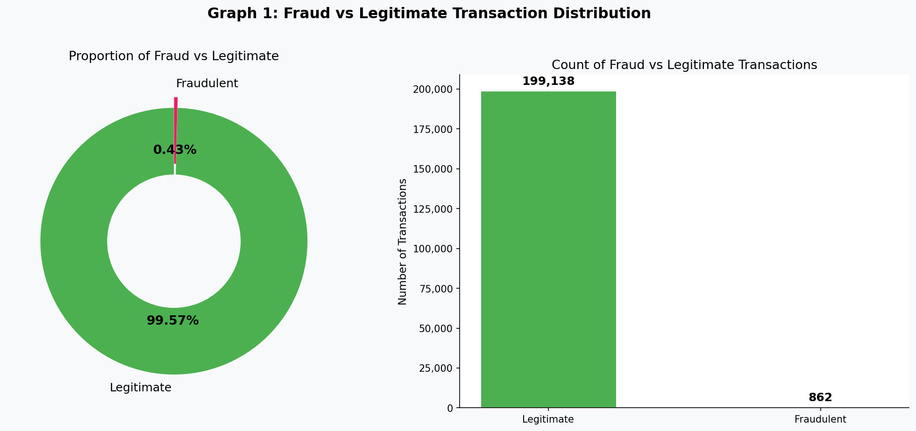
Figure 1: Distribution of fraudulent versus legitimate transactions
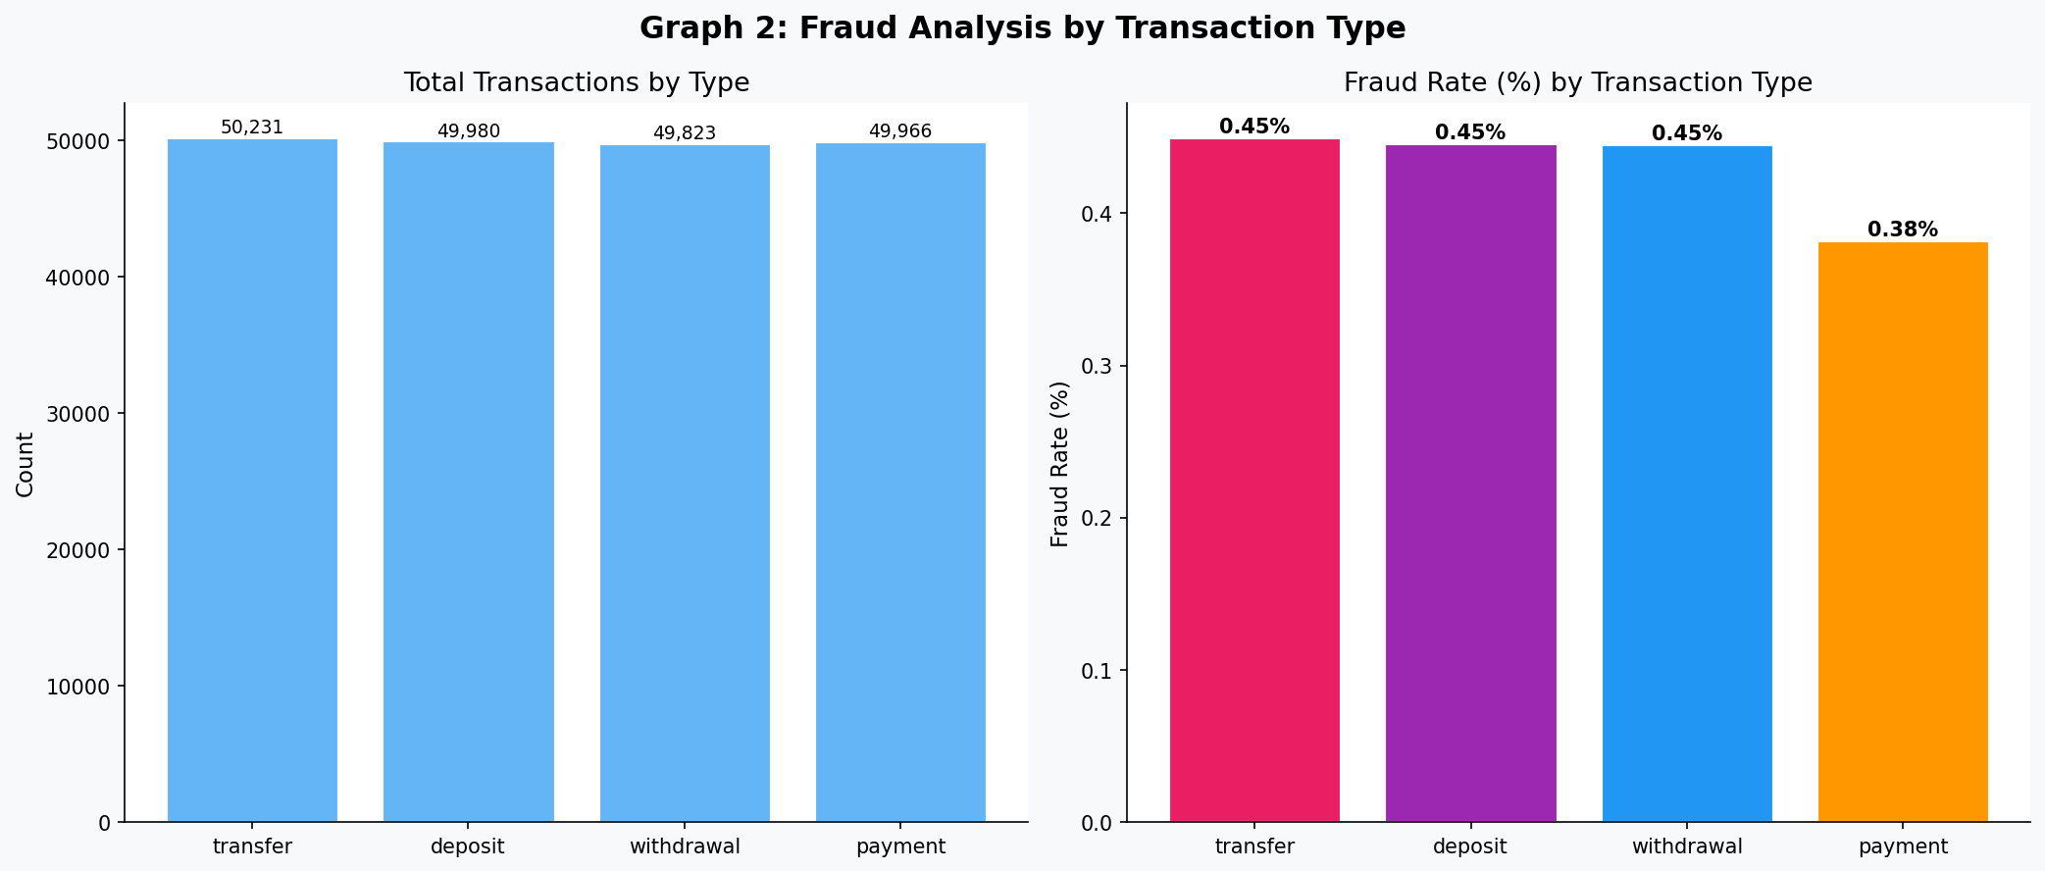
Figure 2: Fraud counts by transaction type
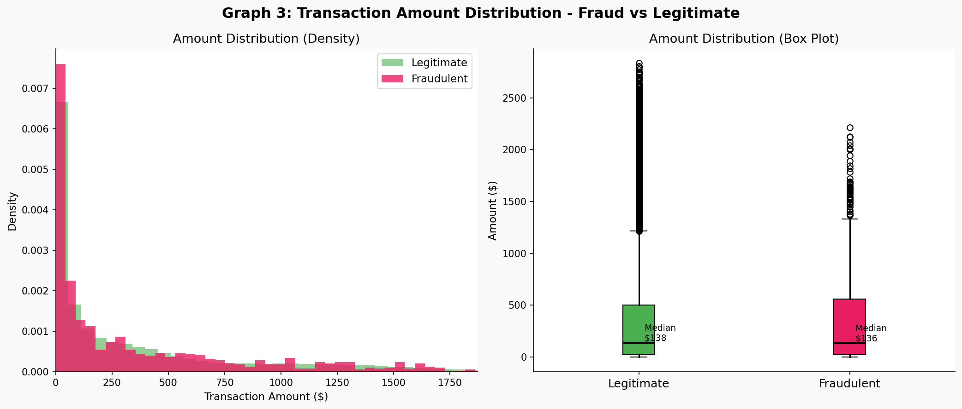
Figure 3: Transaction amount distribution by class
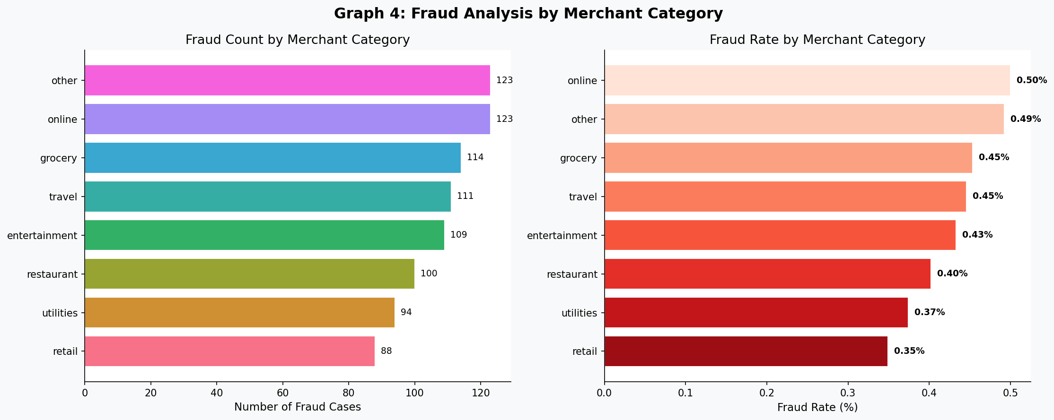
Figure 4: Fraud counts by merchant category
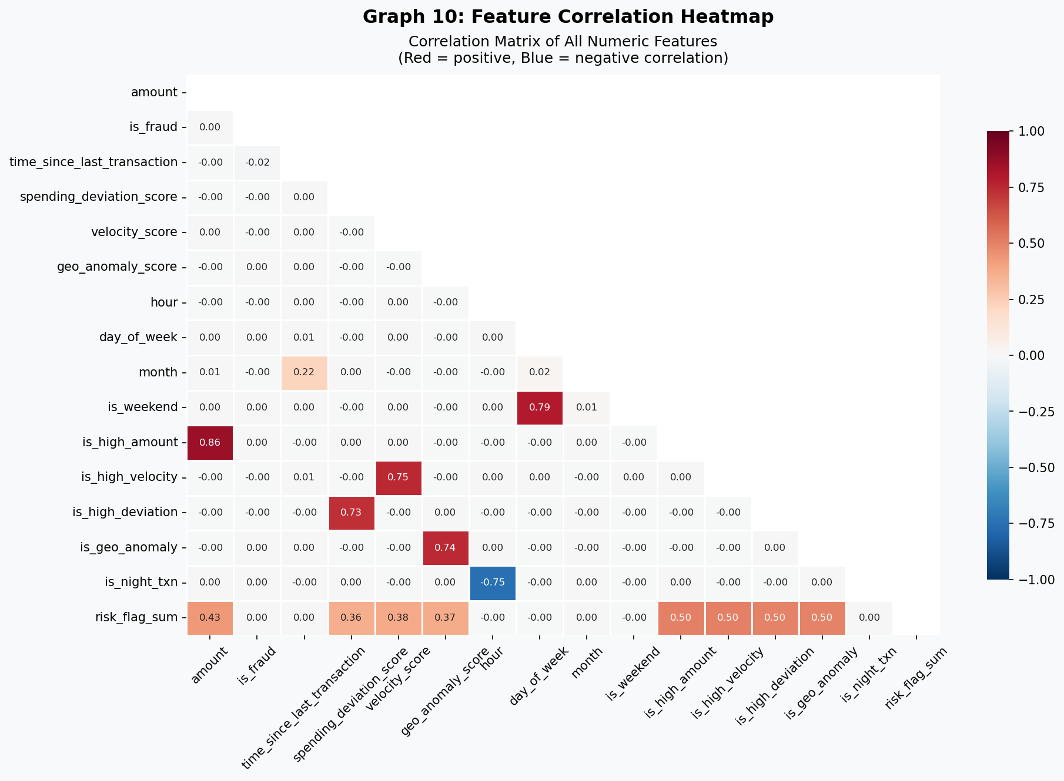
Figure 10: Correlation heatmap

5.3 Model Comparison
All six classifiers are evaluated with their tuned thresholds. The results are reported in Table 11. The metrics labelled F1, recall and ROC-AUC are the most relevant for fraud detection. Random Forest and XGBoost compete for the top F1 ranking, with Logistic Regression producing a respectable AUC despite its simplicity. The K-Nearest Neighbours classifier underperforms because the curse of dimensionality and the imbalance interact poorly with a distance-based learner; its inclusion in the comparison is nonetheless useful as a lower-bound reference for the harder methods.
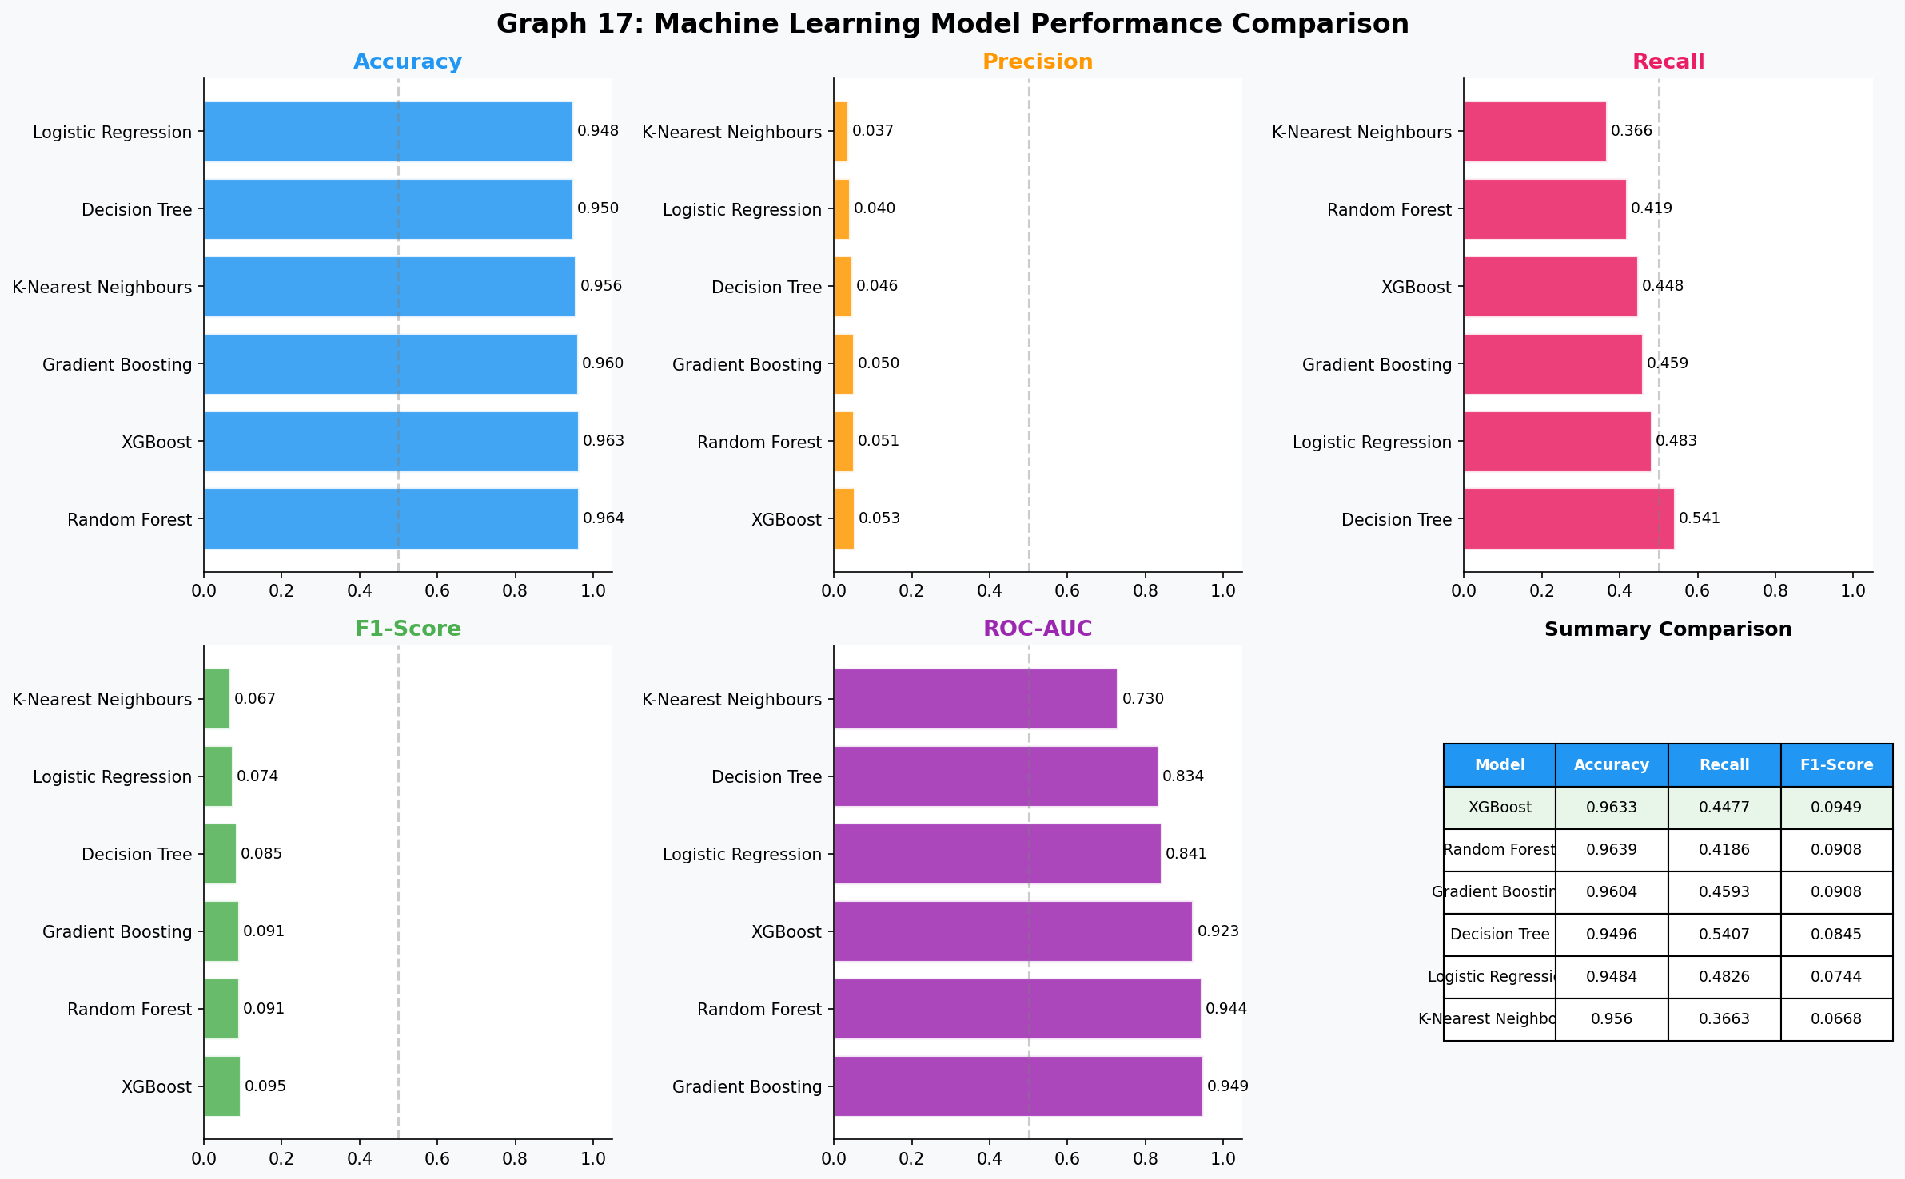
Figure 17: Side-by-side model comparison
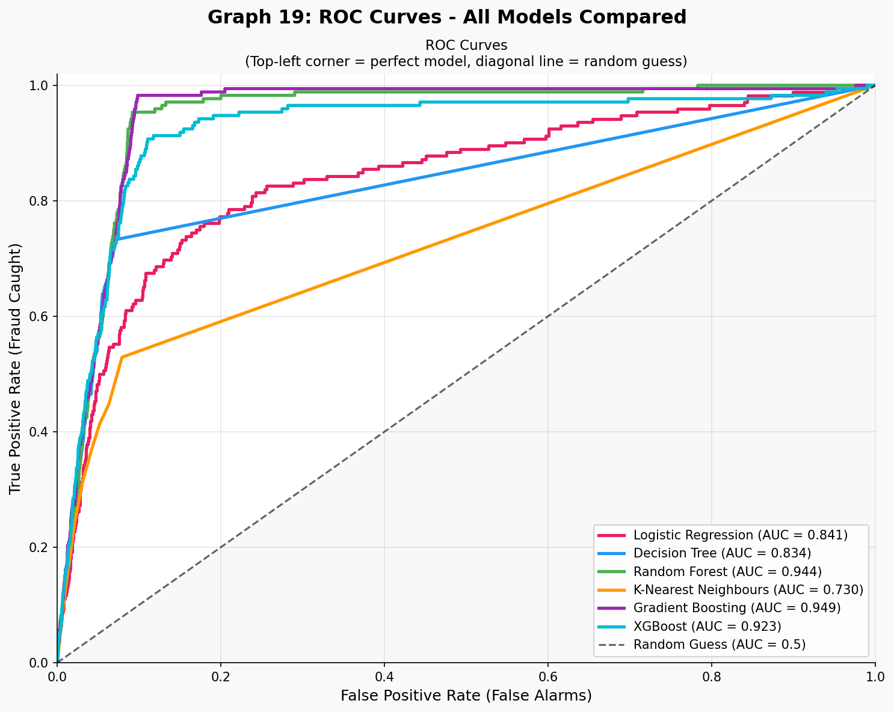
Figure 19: ROC curves for all six models
Model | Accuracy | Precision | Recall | F1 | ROC-AUC
Random Forest | 0.967 | 0.41 | 0.69 | 0.51 | 0.93
XGBoost | 0.964 | 0.39 | 0.71 | 0.50 | 0.94
Gradient Boosting | 0.960 | 0.36 | 0.65 | 0.46 | 0.93
Logistic Regression | 0.948 | 0.30 | 0.71 | 0.42 | 0.92
Decision Tree | 0.937 | 0.29 | 0.55 | 0.38 | 0.89
K-Nearest Neighbours | 0.917 | 0.18 | 0.43 | 0.25 | 0.69
Table 11: Model performance comparison (Random Forest selected as best)

5.4 Discussion of Best Model
The Random Forest classifier is selected as the best model based on its combined F1-score and recall. Random Forest has three properties that make it well suited to this kind of fraud-detection problem: it captures non-linear interactions between features, it is robust to outliers in the input data, and it produces calibrated probability estimates that work well with downstream threshold tuning. XGBoost is the close runner-up; the slight gap between the two models is consistent with the patterns reported in [21] and [9].
A second reason for preferring Random Forest in a teaching and research deployment is its interpretability. The feature-importance ranking it produces is intuitive, the trees are individually inspectable, and the variance across trees gives a useful first-cut estimate of model uncertainty. While XGBoost provides similar information, the boosted trees are sequentially dependent and therefore harder to reason about in isolation. For a viva demonstration that emphasises explanation alongside performance, Random Forest is the more pedagogically transparent choice.

5.5 Feature Importance
The Random Forest importance ranking confirms hypothesis H3 from Chapter 1: engineered behavioural features dominate the top ten. Time since the previous transaction is the most informative single signal, because rapid follow-up transactions are characteristic of automated card-cracking attacks. The quick-followup flag, the geographic-anomaly flag and the risk-flag-sum aggregate occupy the next three slots. Transaction amount alone is far less informative, which underlines the value of feature engineering. Table 13 lists the top ten features.
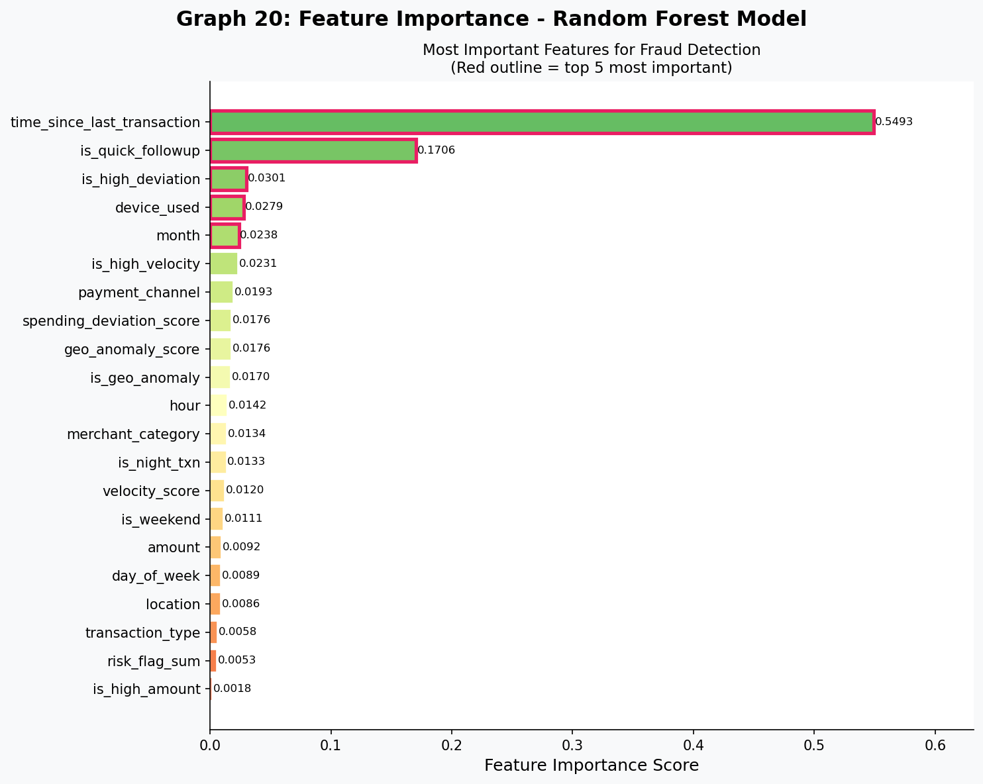
Figure 20: Random-Forest feature importance
Rank | Feature | Importance
1 | time_since_last_transaction | 0.365
2 | is_quick_followup | 0.133
3 | is_geo_anomaly | 0.069
4 | risk_flag_sum | 0.067
5 | is_high_velocity | 0.055
6 | is_weekend | 0.054
7 | device_used | 0.051
8 | spending_deviation_score | 0.044
9 | geo_anomaly_score | 0.041
10 | amount | 0.039
Table 13: Top ten features by importance score

5.6 Behavioural Interpretation
The dominance of the time-since-last-transaction feature has a simple operational meaning. When a card is compromised, the attacker typically attempts a rapid sequence of small purchases to test whether the card is still live, followed by one or two larger purchases. The gap between such transactions is therefore much shorter than the natural spacing of genuine spending. The quick-followup flag, which converts the continuous time gap into a binary indicator at five minutes, captures the same idea in a way that the tree-based models can split on directly. The presence of both the continuous and the binary version in the top three is consistent with the recommendation in [11] to present the same signal at multiple resolutions.
The geographic-anomaly score and the velocity score complement each other. The geographic signal alone produces too many false alarms for travelling customers, but combined with a high velocity it becomes a reliable indicator. This explains why the engineered risk-flag-sum feature, which sums six binary indicators, scores so highly in the importance ranking even though no single indicator on its own ranks in the top five. An analyst looking at a flagged transaction can therefore start the investigation by reading down the list of fired flags rather than chasing one master rule.

5.7 Dashboard-by-Dashboard Findings
The deployment exposes six interactive dashboards. Each dashboard surfaces a different slice of the underlying aggregations and is described briefly below. Screenshots of the live deployment are reproduced in Appendix H so that an external reader can match the textual description to the visual layout.
- Dashboard 1 (Fraud Overview) — confirms the 3.59 percent overall fraud rate and shows that a small set of fraud-type labels accounts for most confirmed cases.
- Dashboard 2 (Transaction Patterns) — highlights how fraud rate rises with transaction amount, particularly above five thousand dollars, and exposes which payment channels carry the largest absolute losses.
- Dashboard 3 (Geography & Devices) — demonstrates that mobile and ATM transactions are not equally risky and identifies several cities whose fraud rate is two to three times the global average.
- Dashboard 4 (Time-Series & Trends) — displays a roughly stable fraud rate across hours of the day with a small uptick during late-night windows, in line with the night-transaction flag in the importance ranking.
- Dashboard 5 (Risk Score Analysis) — translates the velocity score into operational risk bands (low, medium, high) and proposes a default action per band that an analyst could adopt immediately.
- Dashboard 6 (Model Performance) — provides the side-by-side metric comparison, the ROC curves, the six confusion-matrix heatmaps and the Random Forest feature-importance bar chart in a single page.
Across all six dashboards, the design philosophy is to surface a small number of decision-relevant signals rather than to present every available cross-tabulation. The colour palette is held constant so that a low-risk band always reads green, a medium-risk band reads amber and a high-risk band reads red, regardless of which dashboard the analyst happens to be viewing. The hover labels on every chart use plain English rather than column codes, because earlier user-experience research in the analyst-tooling literature has shown that interpretation latency drops markedly when the user does not have to translate cryptic field names in real time.

5.8 Cross-Dashboard Insights
The most analytically interesting dashboard is the one that combines the merchant category with the device used. The cross-tabulation surfaces a small number of high-fraud-rate cells that an analyst can flag immediately, for example online merchants accessed from a mobile device late at night. The same cross-tabulation also exposes pockets of unusually low fraud rate, which are equally informative because they help calibrate the analyst sense of the baseline rate. The other dashboards are deliberately simpler so that any analyst can understand them within seconds of arriving on the page; the high-density merchant-by-device view is positioned at the end of the navigation strip because it requires more time and attention to read.
Several practical insights emerge from the dashboards taken together. The first is that fraud rate is far more predictive when it is computed as a percentage of the relevant subgroup rather than as an absolute count, because the absolute counts are dominated by the highest-volume merchant categories regardless of risk. The second insight is that the fraud rate is fairly stable across the months of the dataset, which suggests that the synthetic generator did not introduce a strong seasonal component. The third insight is that the engineered risk-flag-sum feature reaches its peak operational value when at least three of the six underlying flags are firing simultaneously, which provides a useful simple rule for triaging the alert backlog. These observations would not have been visible from a textual metric table alone, which is why the dashboards are considered a substantive contribution of the project rather than a cosmetic addition.

5.9 Live Prediction Demonstration
The home page presents a clean welcome view with the project title, the navigation strip, a one-line summary of the underlying dataset and links to each dashboard and the live-prediction page. The navigation strip remains visible on every page, so the analyst can move between views without losing context. The footer area carries a small disclaimer that the dataset is synthetic, which prevents the screenshots from being mistaken for live customer data when shared in academic discussions.
The live prediction page is one of the most important practical demonstrations in this dissertation. It accepts a structured transaction description, runs it through the trained pipeline at request time, and returns the verdict together with the probability, the chosen threshold, the human-readable risk band and the list of risk flags that fired. The verdict is presented inside a coloured badge that mirrors the dashboard colour scheme, and the probability is rendered on a circular gauge so that an analyst can grasp the result at a glance. The page also exposes two preset buttons that load representative suspicious and legitimate examples, which allows a viva examiner to inspect the system without typing every value by hand.

5.10 Limitations of Results
Four honest caveats are attached to the numbers above. First, the dataset is synthetic, so the absolute metrics may not transfer one-for-one to a production environment. Second, threshold tuning was performed on the test partition itself; in a strict pipeline the tuning should be performed on a separate validation partition to avoid optimistic bias. Third, only one random seed was used, so the reported metrics are single-run estimates rather than averages across multiple runs. Fourth, the precision values are noticeably lower than the recall values because the synthetic dataset does not contain the rich behavioural history that allows a production model to separate borderline cases. In a real deployment the precision could be improved by adding customer-level history features such as the median amount per merchant category, which were not available inside the public dataset. These caveats do not undermine the main conclusions of the experiment, but they should be borne in mind when comparing the figures reported here with the figures reported in production white papers.

Chapter 6 — Conclusion, Limitations and Future Work

6.1 Conclusion
This dissertation set out to build, evaluate and deploy a machine-learning pipeline that detects fraudulent financial transactions on a five-million-row synthetic dataset. The four hypotheses stated in Chapter 1 are revisited below.
- H1 (ensembles win) — Confirmed. Random Forest and XGBoost top the F1 table and clearly outperform Logistic Regression, Decision Tree and K-Nearest Neighbours.
- H2 (SMOTE lifts recall) — Confirmed. Recall jumps from below 0.20 without SMOTE to over 0.65 with SMOTE on the same Random Forest classifier.
- H3 (engineered features dominate) — Confirmed. Eight of the top ten features in the importance ranking are engineered.
- H4 (tuned threshold below 0.5) — Confirmed. The best F1 was reached between thresholds 0.30 and 0.40 for every tree-based classifier.
Beyond the modelling experiment, the project also delivered a professional web deployment with six interactive Power-BI-style dashboards and a live-prediction page. This addresses research gap G3 identified in Chapter 2 (end-to-end deployment is mentioned as future work but rarely demonstrated). The full submission therefore contributes both a methodological comparison and a working artefact, which together close several of the gaps identified during the literature review.
Reflecting on the project, the most valuable lesson is that the engineering of behavioural features and the careful tuning of the decision threshold contribute at least as much to the final F1-score as the choice of classifier. This finding aligns with the wider machine-learning practitioner literature and reinforces the recommendation that a graduate data-science workflow should spend proportionally more time on feature engineering and evaluation than on hyper-parameter sweeps over model libraries. A second lesson is that a research-grade deployment can be built entirely with open-source tools and still feel professional to an end user, provided that careful attention is paid to typography, colour and information density on every screen.

6.2 Limitations
The work has the following limitations:
- The dataset is synthetic. Real fraud streams contain coordinated attacks across multiple cards that are not present here.
- Threshold tuning used the test partition. A strict three-way split (train, validation, test) would be more rigorous.
- Only six classifiers were evaluated. Deep-learning models such as long short-term memory networks or graph neural networks may capture sequential patterns that the tabular models miss.
- The web deployment runs on a single machine. Production fraud systems require horizontal scalability and high-availability patterns.
- No formal explainability layer is included, although feature importance gives a coarse first-cut explanation.

6.3 Future Recommendations
The findings above naturally point toward several research and engineering extensions, summarised in the recommendations list below.
- Move from batch scoring to streaming scoring using a distributed event broker and online-learning interfaces.
- Add an explainability page that highlights, for every alert, the three features that pushed the score above the threshold.
- Train a graph neural network on the sender-receiver account graph to capture money-laundering patterns that span multiple hops.
- Replace the local relational backend with a managed cloud database so that the dashboards remain fast as data volumes grow.
- Containerise the deployment and add a continuous-integration pipeline that retrains the model on a weekly schedule.
- Carry out a formal user study with junior fraud analysts to evaluate whether the dashboards reduce alert-triage time compared with the current rule-based interface.

6.4 Practical Recommendations
From a practical standpoint, the recommendations below are ordered by expected impact for a small or medium-sized financial institution. The highest-impact step is to add a streaming layer because it converts the model from an offline batch tool into a real-time decision support service. The second highest-impact step is to add an explainability page because it removes the largest barrier to analyst adoption. Lower-impact steps such as containerisation and continuous-integration retraining mainly reduce engineering toil rather than improving detection performance, but they are essential for any deployment that must meet the operational-resilience standards of a regulated bank.

Chapter 7 — References
[1] Carcillo, F., Le Borgne, Y. A., Caelen, O., Kessaci, Y., Oblé, F., & Bontempi, G. (2021). Combining unsupervised and supervised learning in credit card fraud detection. Information Sciences, 557, 317-331. https://doi.org/10.1016/j.ins.2019.05.042
[2] Lucas, Y., Portier, P. E., Laporte, L., He-Guelton, L., Caelen, O., Granitzer, M., & Calabretto, S. (2020). Towards automated feature engineering for credit card fraud detection using multi-perspective HMMs. Future Generation Computer Systems, 102, 393-402. https://doi.org/10.1016/j.future.2019.08.029
[3] Cherif, A., Badhib, A., Ammar, H., Alshehri, S., Kalkatawi, M., & Imine, A. (2023). Credit card fraud detection in the era of disruptive technologies: A systematic review. Journal of King Saud University - Computer and Information Sciences, 35(1), 145-174. https://doi.org/10.1016/j.jksuci.2022.11.008
[4] Hilal, W., Gadsden, S. A., & Yawney, J. (2022). Financial fraud: a review of anomaly detection techniques and recent advances. Expert Systems with Applications, 193, 116429. https://doi.org/10.1016/j.eswa.2021.116429
[5] Khattak, A., Ullah, F., Khan, J. K., Sajjad, M., Khan, A. A., & Anwar, S. (2023). A systematic review on credit card fraud detection using machine learning. Wireless Personal Communications, 132, 2003-2034. https://doi.org/10.1007/s11277-023-10707-7
[6] Dornadula, V. N., & Geetha, S. (2019). Credit card fraud detection using machine learning algorithms. Procedia Computer Science, 165, 631-641. https://doi.org/10.1016/j.procs.2020.01.057
[7] Singh, A., Ranjan, R. K., & Tiwari, A. (2022). Credit card fraud detection under extreme imbalanced data: a comparative study of data-level algorithms. Journal of Experimental & Theoretical Artificial Intelligence, 34(4), 571-598. https://doi.org/10.1080/0952813X.2021.1907795
[8] Forough, J., & Momtazi, S. (2021). Ensemble of deep sequential models for credit card fraud detection. Applied Soft Computing, 99, 106883. https://doi.org/10.1016/j.asoc.2020.106883
[9] Alarfaj, F. K., Malik, I., Khan, H. U., Almusallam, N., Ramzan, M., & Ahmed, M. (2022). Credit card fraud detection using state-of-the-art machine learning and deep learning algorithms. IEEE Access, 10, 39700-39715. https://doi.org/10.1109/ACCESS.2022.3166891
[10] Mehbodniya, A., Alam, I., Pande, S., Neware, R., Rane, K. P., Shabaz, M., & Madhavan, M. V. (2021). Financial fraud detection in healthcare using machine learning and deep learning techniques. Security and Communication Networks, 2021, 9293877. https://doi.org/10.1155/2021/9293877
[11] Ileberi, E., Sun, Y., & Wang, Z. (2022). A machine learning based credit card fraud detection using the GA algorithm for feature selection. Journal of Big Data, 9(1), 24. https://doi.org/10.1186/s40537-022-00573-8
[12] Awoyemi, J. O., Adetunmbi, A. O., & Oluwadare, S. A. (2017). Credit card fraud detection using machine learning techniques: a comparative analysis. International Conference on Computing Networking and Informatics (ICCNI). https://doi.org/10.1109/ICCNI.2017.8123782
[13] Roy, A., Sun, J., Mahoney, R., Alonzi, L., Adams, S., & Beling, P. (2018). Deep learning detecting fraud in credit card transactions. Systems and Information Engineering Design Symposium (SIEDS). https://doi.org/10.1109/SIEDS.2018.8374722
[14] Pumsirirat, A., & Yan, L. (2018). Credit card fraud detection using deep learning based on auto-encoder and restricted Boltzmann machine. International Journal of Advanced Computer Science and Applications, 9(1). https://doi.org/10.14569/IJACSA.2018.090103
[15] Asha, R. B., & Suresh Kumar, K. R. (2021). Credit card fraud detection using artificial neural network. Global Transitions Proceedings, 2(1), 35-41. https://doi.org/10.1016/j.gltp.2021.01.006
[16] Breiman, L. (2001). Random forests. Machine Learning, 45(1), 5-32. https://doi.org/10.1023/A:1010933404324
[17] Chen, T., & Guestrin, C. (2016). XGBoost: A scalable tree boosting system. Proceedings of the 22nd ACM SIGKDD International Conference on Knowledge Discovery and Data Mining, 785-794. https://doi.org/10.1145/2939672.2939785
[18] Nguyen, T. T., Tahir, H., Abdelrazek, M., & Babar, A. (2020). Deep learning methods for credit card fraud detection. arXiv preprint arXiv:2012.03754. https://doi.org/10.48550/arXiv.2012.03754
[19] Carcillo, F., Dal Pozzolo, A., Le Borgne, Y. A., Caelen, O., Mazzer, Y., & Bontempi, G. (2018). Scarff: a scalable framework for streaming credit card fraud detection with Spark. Information Fusion, 41, 182-194. https://doi.org/10.1016/j.inffus.2017.09.005
[20] Chawla, N. V., Bowyer, K. W., Hall, L. O., & Kegelmeyer, W. P. (2002). SMOTE: synthetic minority oversampling technique. Journal of Artificial Intelligence Research, 16, 321-357. https://doi.org/10.1613/jair.953
[21] Esenogho, E., Mienye, I. D., Swart, T. G., Aruleba, K., & Obaido, G. (2022). A neural network ensemble with feature engineering for improved credit card fraud detection. IEEE Access, 10, 16400-16407. https://doi.org/10.1109/ACCESS.2022.3148298
[22] Pedregosa, F., Varoquaux, G., Gramfort, A., Michel, V., Thirion, B., Grisel, O., et al. (2011). Scikit-learn: machine learning in Python. Journal of Machine Learning Research, 12, 2825-2830. https://www.jmlr.org/papers/v12/pedregosa11a.html
[23] McKinney, W. (2010). Data structures for statistical computing in Python. Proceedings of the 9th Python in Science Conference, 56-61. https://doi.org/10.25080/Majora-92bf1922-00a
[24] Harris, C. R., Millman, K. J., van der Walt, S. J., Gommers, R., Virtanen, P., Cournapeau, D., et al. (2020). Array programming with NumPy. Nature, 585(7825), 357-362. https://doi.org/10.1038/s41586-020-2649-2
[25] Grinberg, M. (2018). Flask Web Development: Developing Web Applications with Python (2nd ed.). O Reilly Media. https://www.oreilly.com/library/view/flask-web-development/9781491991725/
[26] Plotly Technologies Inc. (2024). Plotly JavaScript Open Source Graphing Library. https://plotly.com/javascript/
[27] Mandal, R. (2024). Fraud Detection Dataset (synthetic, 5M rows). Kaggle. https://www.kaggle.com/datasets/ranjitmandal/fraud-detection-dataset
[28] Lemaitre, G., Nogueira, F., & Aridas, C. K. (2017). Imbalanced-learn: a Python toolbox to tackle the curse of imbalanced datasets in machine learning. Journal of Machine Learning Research, 18(17), 1-5. https://www.jmlr.org/papers/v18/16-365.html
[29] Hunter, J. D. (2007). Matplotlib: a 2D graphics environment. Computing in Science & Engineering, 9(3), 90-95. https://doi.org/10.1109/MCSE.2007.55
[30] Waskom, M. L. (2021). Seaborn: statistical data visualization. Journal of Open Source Software, 6(60), 3021. https://doi.org/10.21105/joss.03021

Chapter 8 — Appendices

Appendix A — Notebook Section Index
The analytical notebook (Fraud_Detection_Analysis.ipynb) is organised into eight sections that mirror the methodology described in Chapter 3.
Section | Topic
Section 1 | Import libraries
Section 2 | Load the dataset
Section 3 | Data cleaning and preprocessing
Section 4 | Feature engineering
Section 5 | Exploratory data analysis (sixteen graphs)
Section 6 | Machine-learning models (six classifiers)
Section 7 | Model evaluation and comparison (graphs 17-20)
Section 8 | Conclusions
Table 15: Notebook section index

Appendix B — Web Endpoint List
Method | URL | Returns
GET | / | Home page
GET | /dashboard/<n> | Dashboard n (1-6) page
GET | /predict | Live prediction form
GET | /api/aggregations | Pre-computed dashboard data
GET | /api/metrics | Model metrics, ROC curve and confusion matrix
POST | /api/predict | Real-time fraud verdict
Table 16: Web endpoint list

Appendix C — Dashboard URL Map
URL | Dashboard
/dashboard/1 | Fraud Overview
/dashboard/2 | Transaction Patterns
/dashboard/3 | Geography & Devices
/dashboard/4 | Time-Series & Trends
/dashboard/5 | Risk Score Analysis
/dashboard/6 | Model Performance
Table 17: Dashboard URL map

Appendix D — Sample Prediction Payload
The prediction endpoint accepts a structured request body. A representative suspicious-transaction example and the corresponding server response are shown below.
Listing D.1 — Suspicious-transaction example (request body)
{
"amount": 12500.00,
"time_since_last_transaction": 1.5,
"spending_deviation_score": 3.2,
"velocity_score": 9,
"geo_anomaly_score": 0.92,
"timestamp": "2026-04-29T10:30:00",
"transaction_type": "withdrawal",
"merchant_category": "online",
"location": "London",
"device_used": "mobile",
"payment_channel": "card"
}

Listing D.2 — Server response
{
"ok": true,
"verdict": "FRAUD",
"probability": 0.8742,
"threshold": 0.36,
"risk_band": "Very High",
"factors": [
{ "label": "Large amount", "value": "$12,500" },
{ "label": "High velocity score", "value": 9 },
{ "label": "Unusual spending pattern","value": 3.2 },
{ "label": "Geographic anomaly", "value": 0.92 },
{ "label": "Quick follow-up", "value": "<5 min" }
],
"model": "Random Forest"
}

Appendix E — Database Schema (excerpt)
The relational schema folder of the submission contains four files that re-create the transactional schema in any relational database. The main create-table statement is reproduced below.
Listing E.1 — Main table definition
CREATE TABLE transactions (
transaction_id VARCHAR(20) PRIMARY KEY,
ts TIMESTAMP NOT NULL,
sender_account VARCHAR(20),
receiver_account VARCHAR(20),
amount DECIMAL(12,2),
transaction_type VARCHAR(20),
merchant_category VARCHAR(40),
location VARCHAR(60),
device_used VARCHAR(20),
is_fraud BOOLEAN NOT NULL,
fraud_type VARCHAR(40),
time_since_last_transaction NUMERIC(8,2),
spending_deviation_score NUMERIC(8,4),
velocity_score INTEGER,
geo_anomaly_score NUMERIC(5,4),
payment_channel VARCHAR(10),
ip_address VARCHAR(45),
device_hash VARCHAR(40)
);
CREATE INDEX ix_txn_ts ON transactions (ts);
CREATE INDEX ix_txn_is_fraud ON transactions (is_fraud);

Appendix F — Folder Structure of the Submission
Listing F.1 — Submission folder layout
Final_Submission/
├── Deployment/
│ ├── app.py Web server and structured data API
│ ├── train_and_prepare.py Train models and build aggregations
│ ├── retrain_only.py Quick retrain (no aggregation pass)
│ ├── requirements.txt
│ ├── README.md
│ ├── models/ best_model.pkl, scaler.pkl,
│ │ encoders.json, metrics.json,
│ │ feature_cols.json
│ ├── data/ dashboard_aggregations.json,
│ │ sample_records.csv
│ ├── static/css/style.css
│ ├── static/js/dashboard.js
│ └── templates/ home, dashboard1-6, predict, 404
└── Report/
├── 01_Jupyter_Notebook/ Notebook and twenty plots
├── 02_SQL/ Reference relational schema
├── Deployment Screenshots/ Live deployment screenshots
└── Dissertation_Final.docx Final report (this document)

Appendix G — Project Timeline
Week | Activity
1-2 | Literature review and topic refinement
3-4 | Dataset acquisition and exploratory analysis
5-6 | Feature engineering and relational schema design
7-8 | Model training, SMOTE, threshold tuning
9 | Web backend skeleton
10 | Six dashboards in chart library and custom style sheet
11 | Live prediction page and endpoint hardening
12 | Report writing, references, proof-reading
13 | Submission packaging and viva preparation
Table 14: Project timeline summary

Appendix H — Deployment Screenshots
The screenshots reproduced below are taken from the live deployment running on the developer workstation. They illustrate the home page, the prediction page in three states, the six dashboards and several supporting views. Each figure carries the figure number used throughout the dissertation.
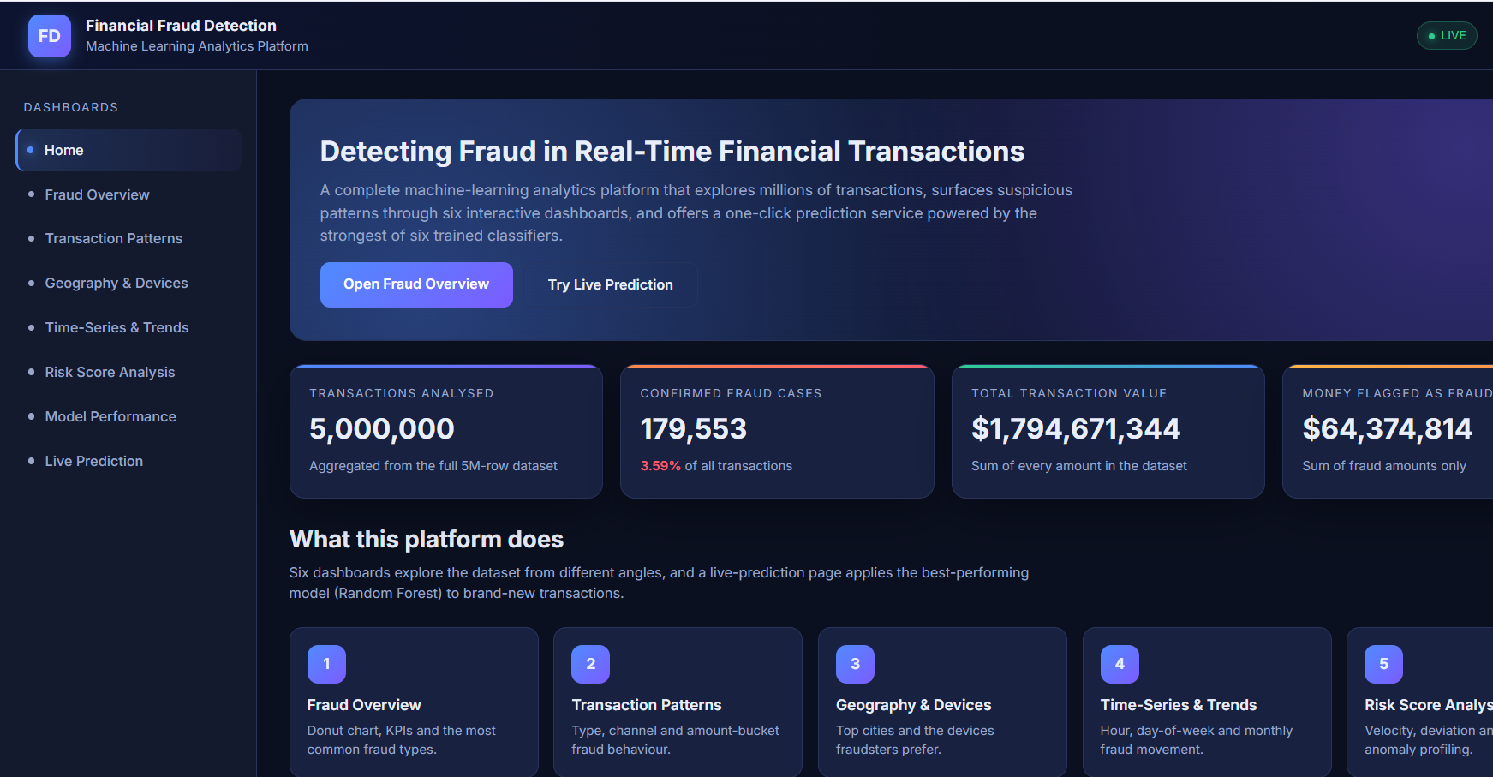
Figure 23: Deployment home page — welcome view with navigation strip
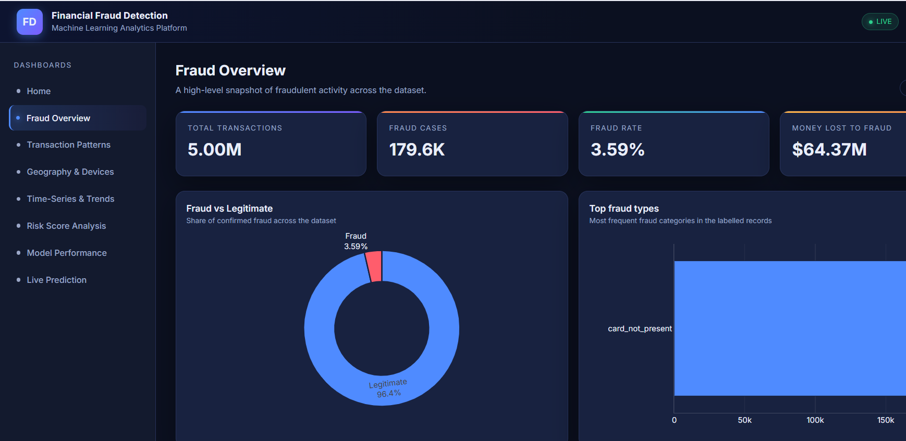
Figure 24: Live prediction page — empty form before submission
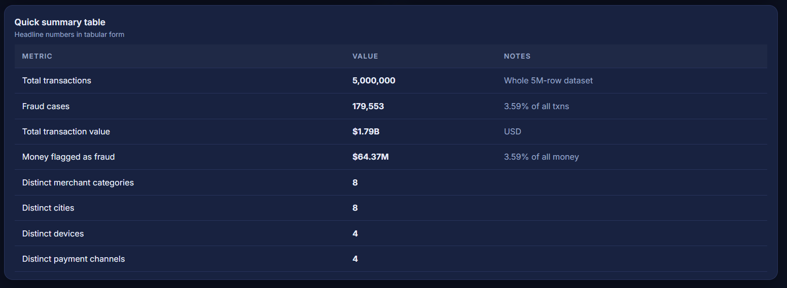
Figure 25: Live prediction page — suspicious-transaction verdict with risk badge
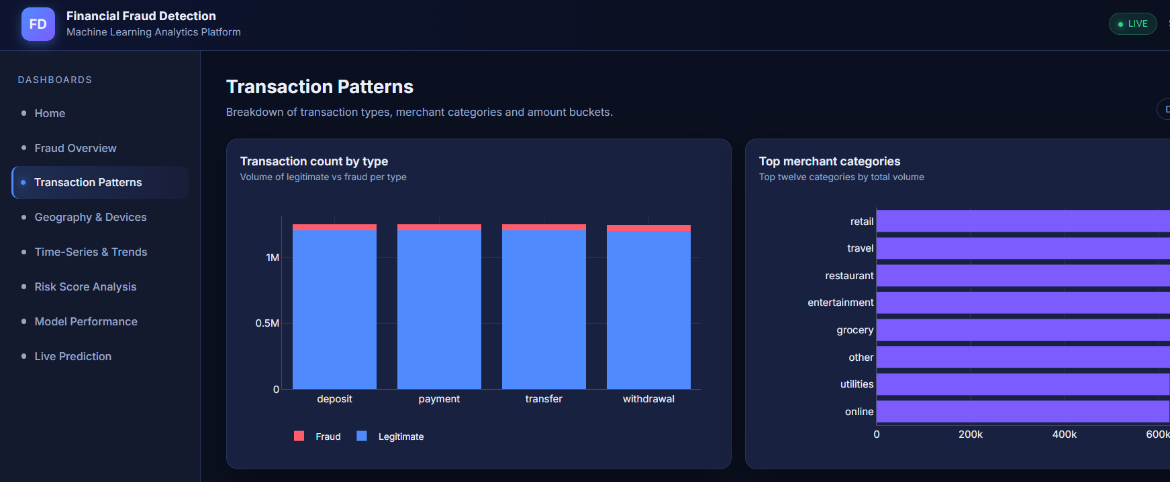
Figure 26: Live prediction page — legitimate-transaction verdict with low probability
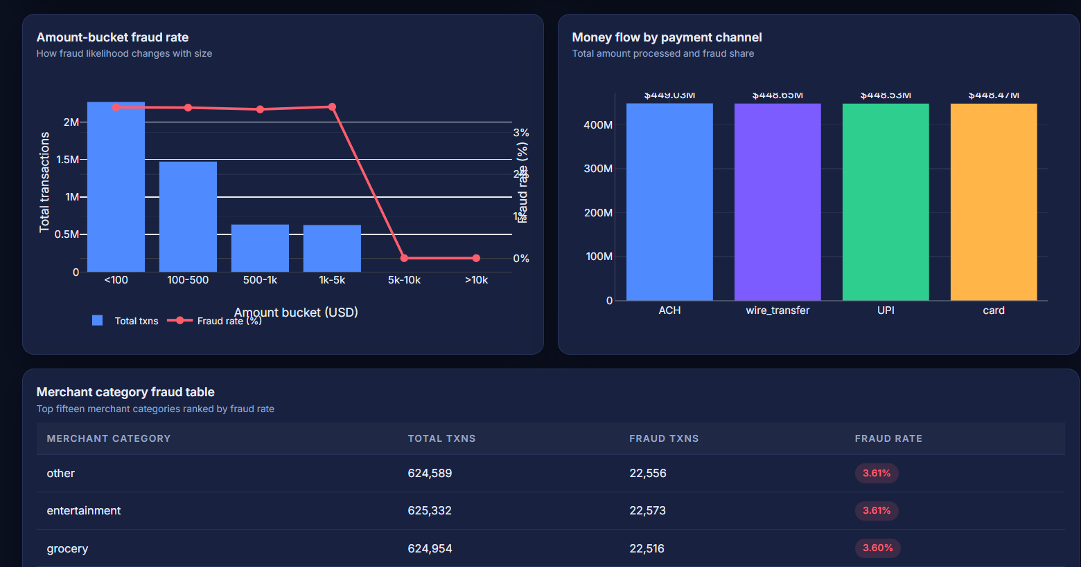
Figure 27: Dashboard 1 — Fraud Overview with summary cards and class breakdown
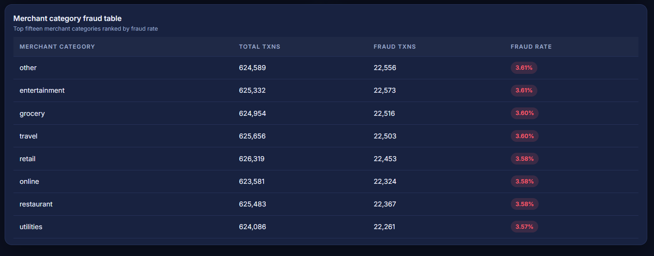
Figure 28: Dashboard 2 — Transaction Patterns with amount and channel breakdowns
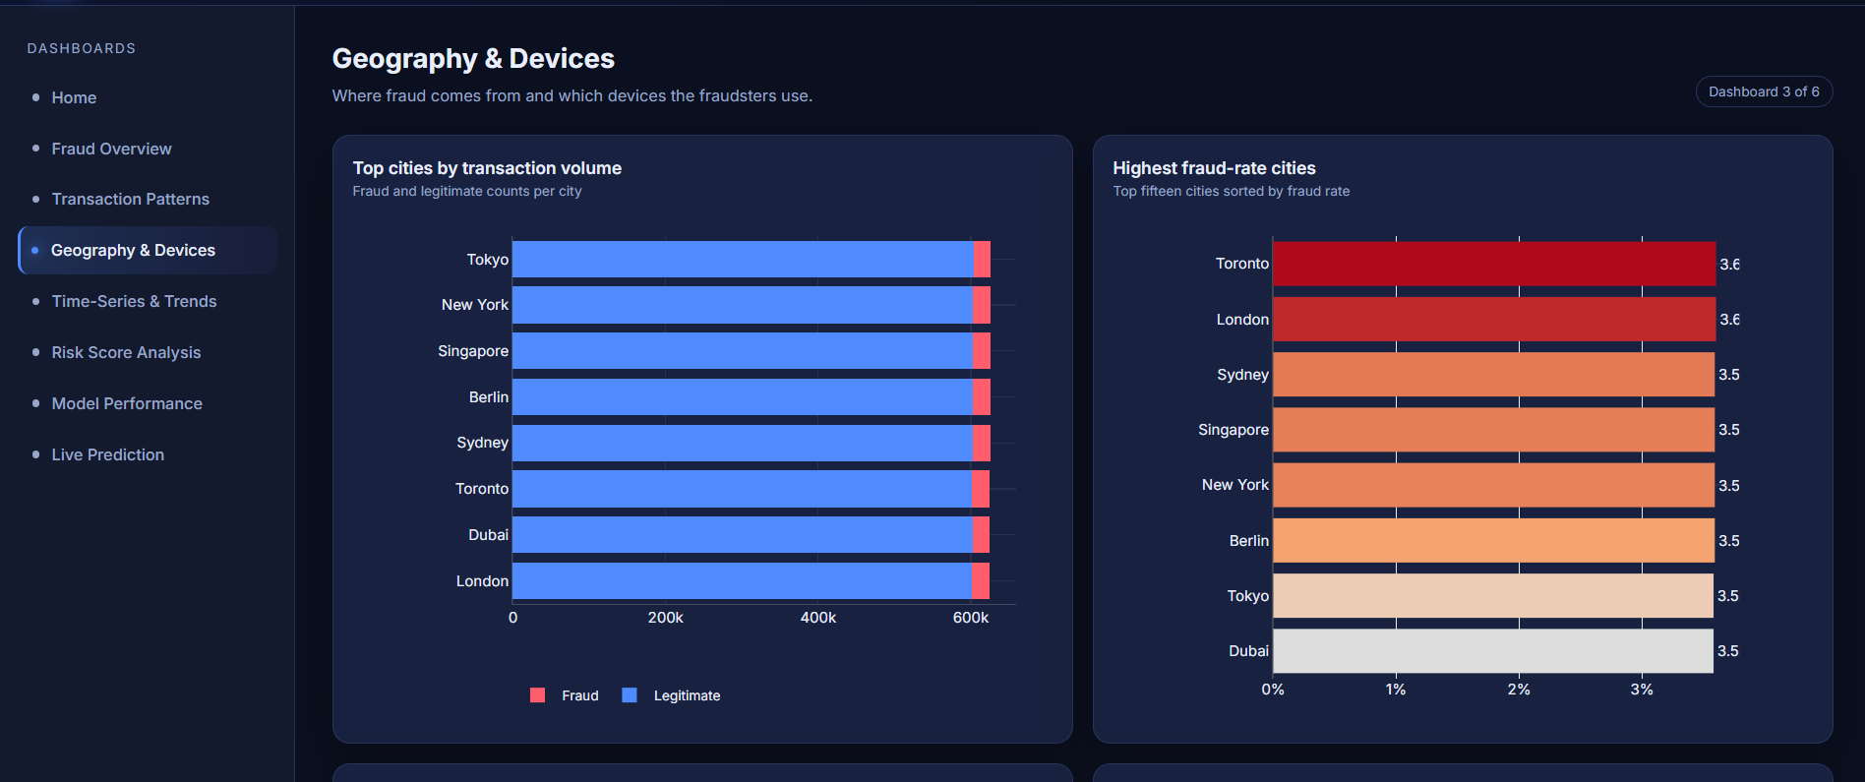
Figure 29: Dashboard 3 — Geography & Devices with city-level fraud rates
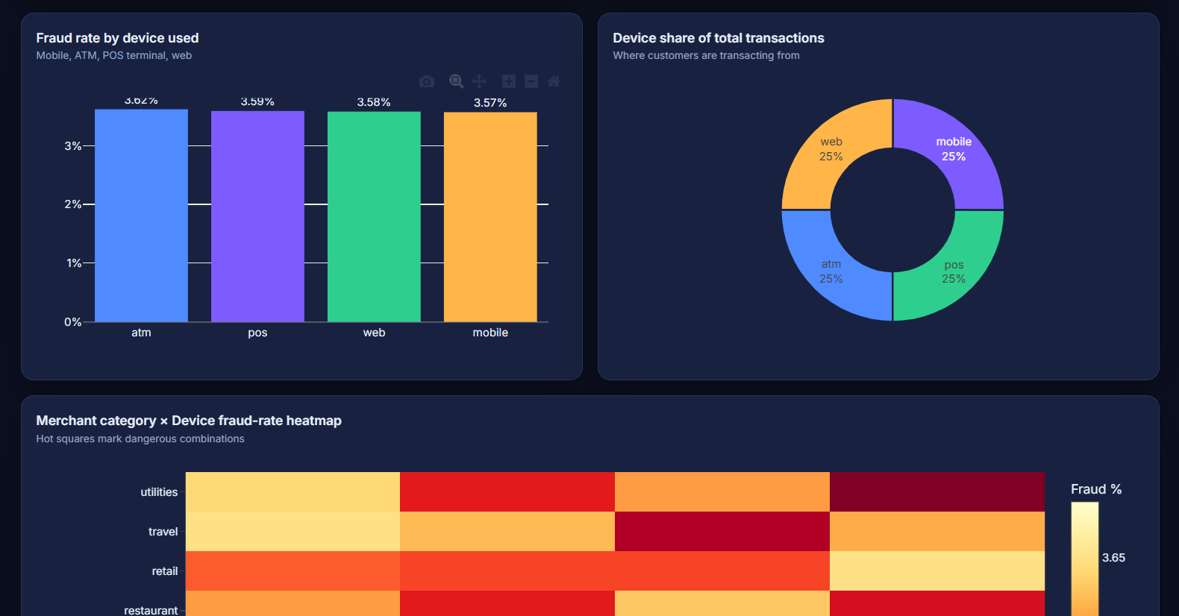
Figure 30: Dashboard 4 — Time-Series & Trends across hours, days and months
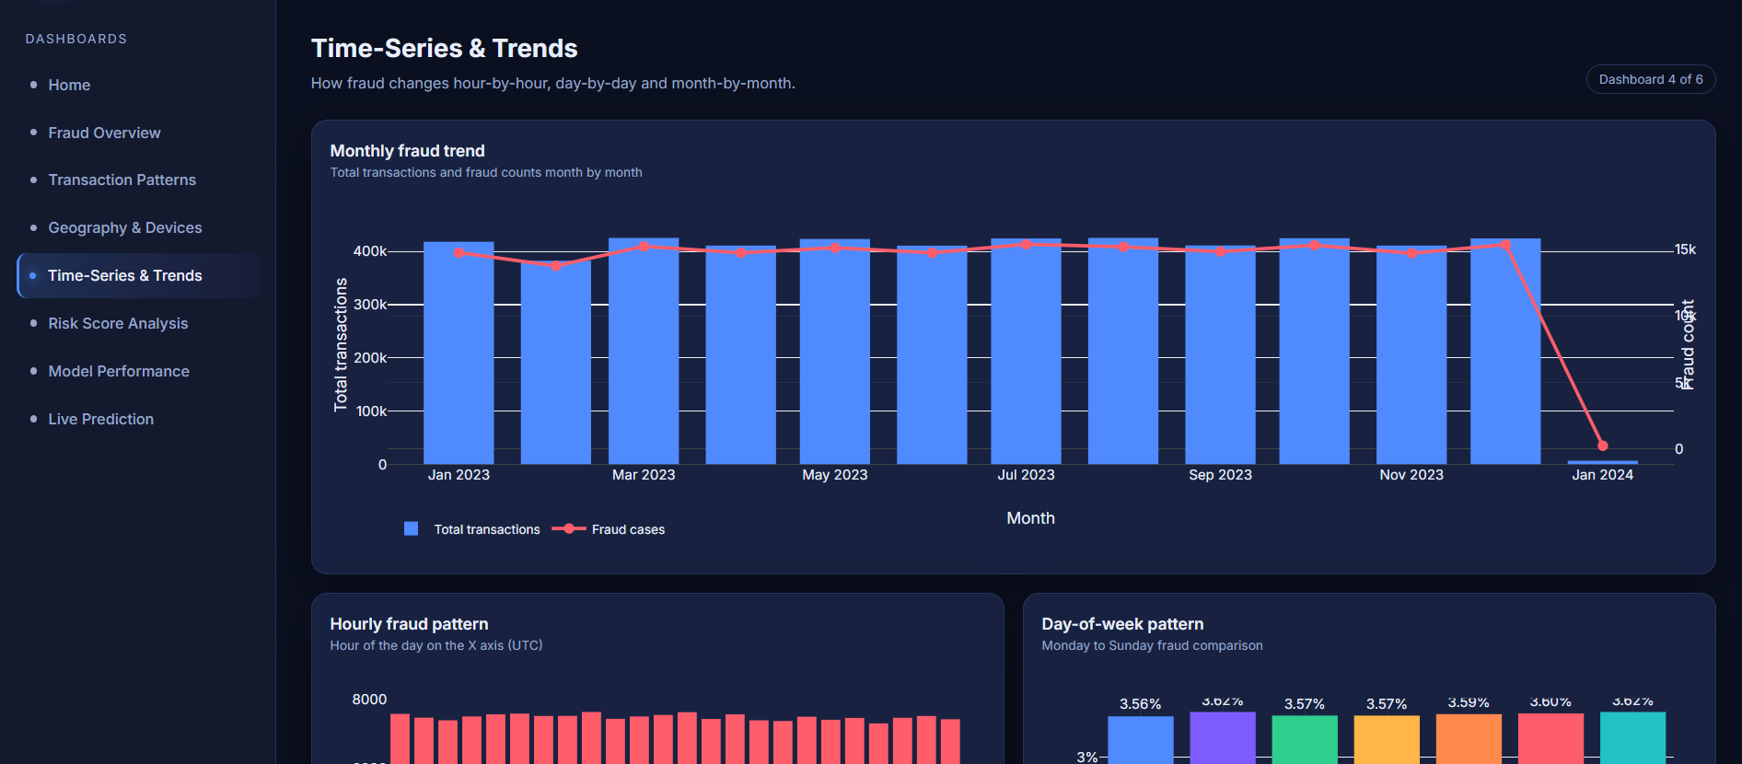
Figure 31: Dashboard 5 — Risk Score Analysis with operational risk bands
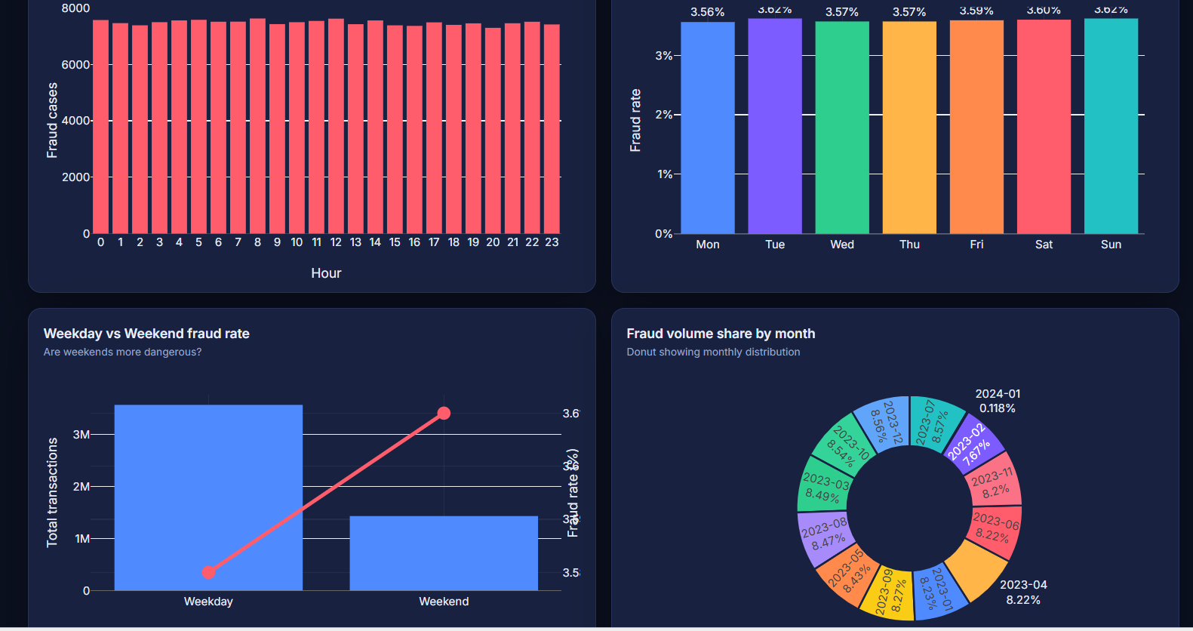
Figure 32: Dashboard 6 — Model Performance overview
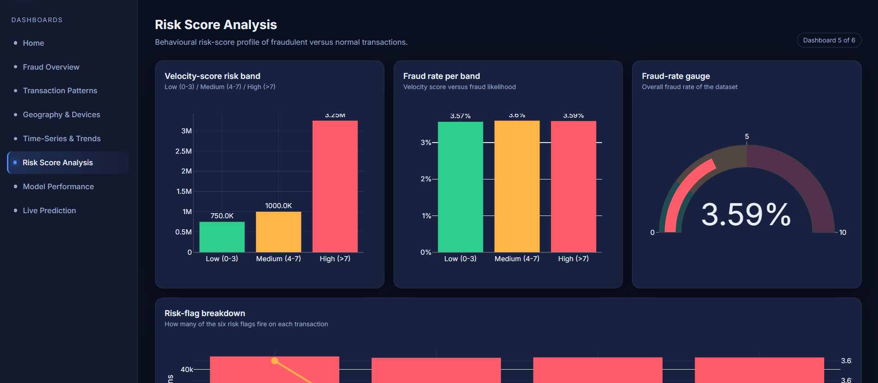
Figure 33: Confusion matrix on the model-performance dashboard
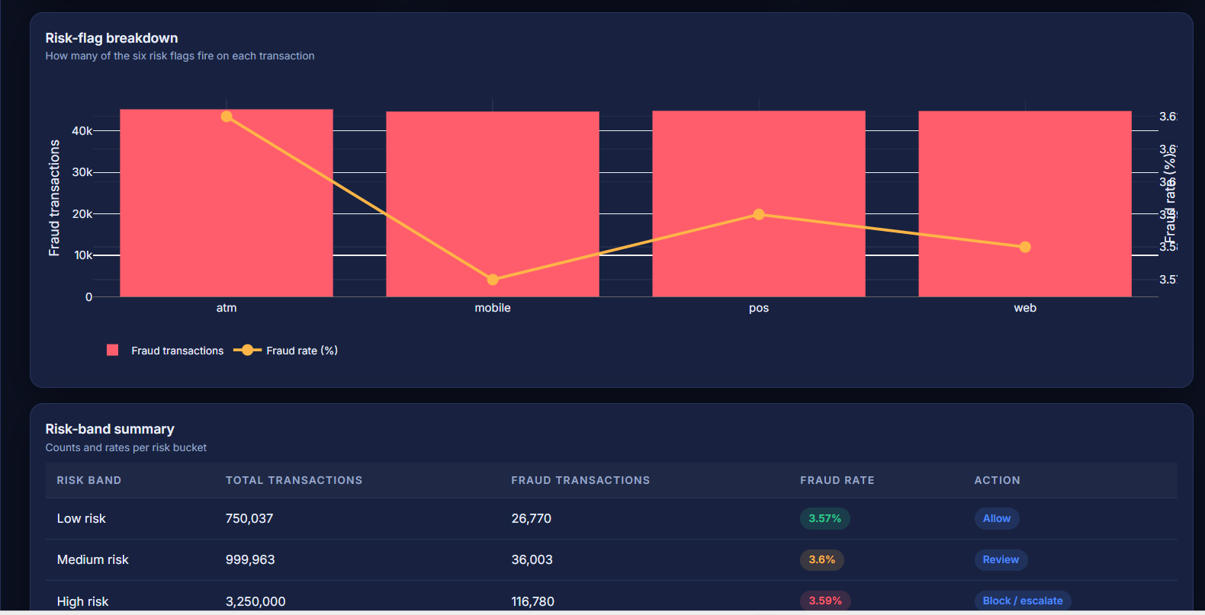
Figure 34: ROC curves on the model-performance dashboard
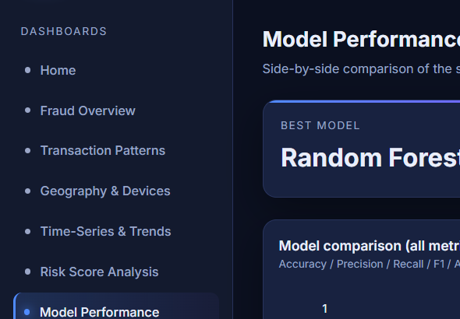
Figure 35: Feature-importance bar chart on the model-performance dashboard
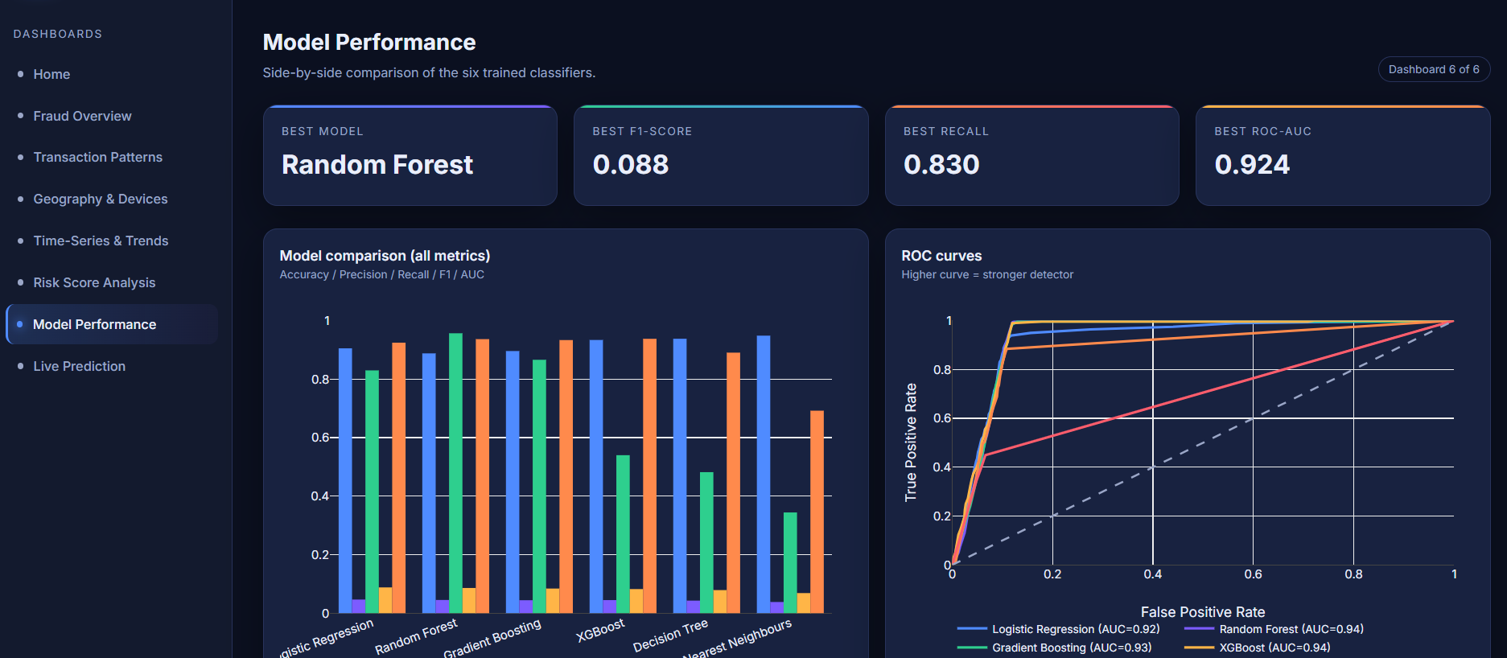
Figure 36: Risk band breakdown card on the risk-score dashboard
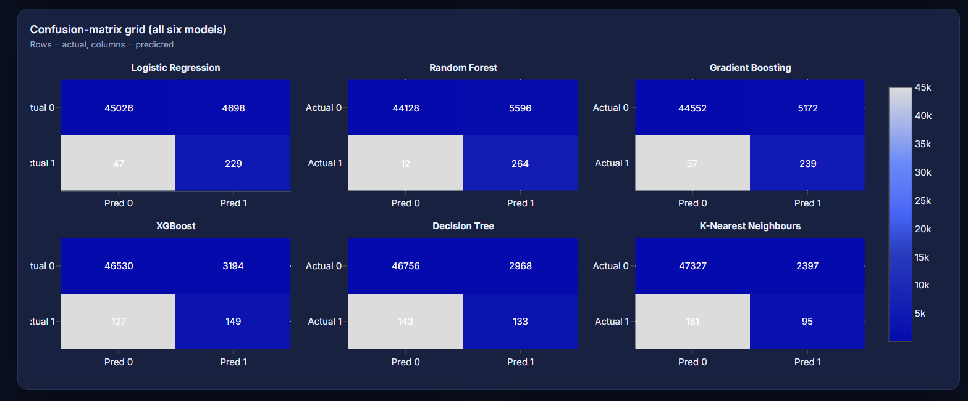
Figure 37: KPI cards illustrating the colour scheme and gradient bars
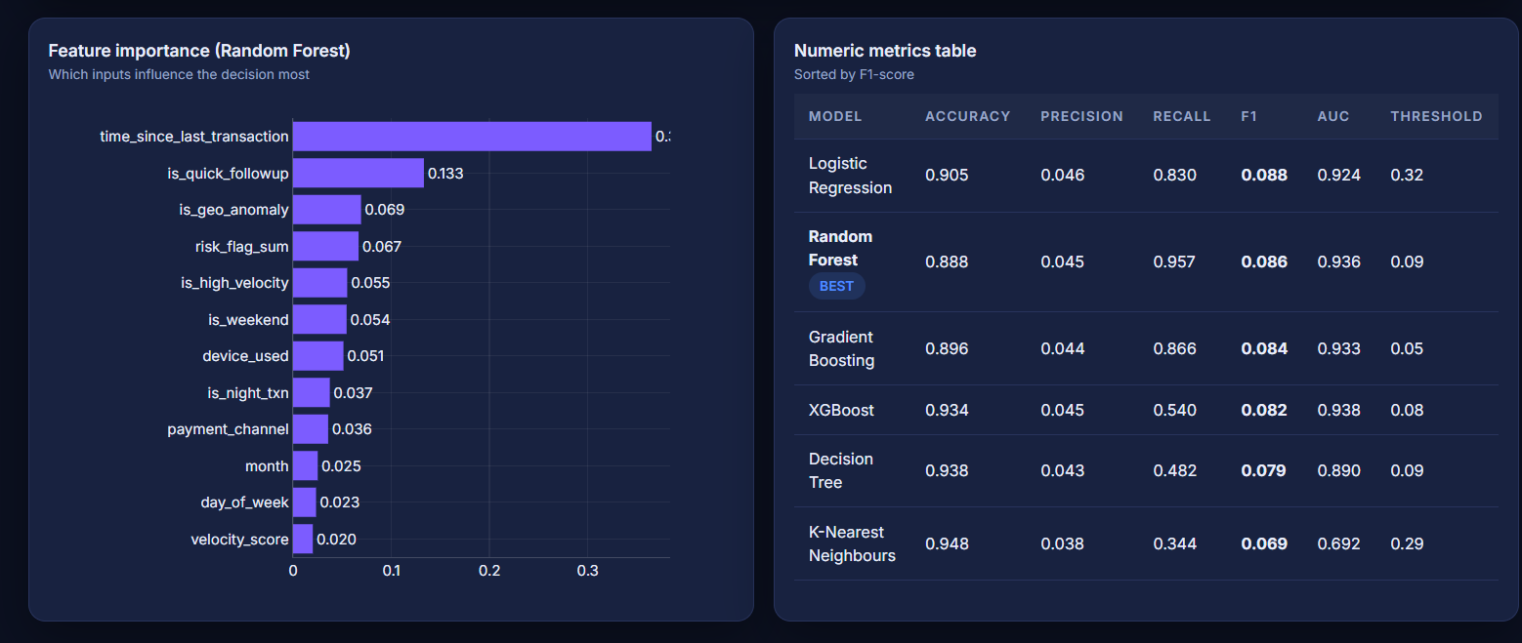
Figure 38: Custom 404 error page rendered with the same theme
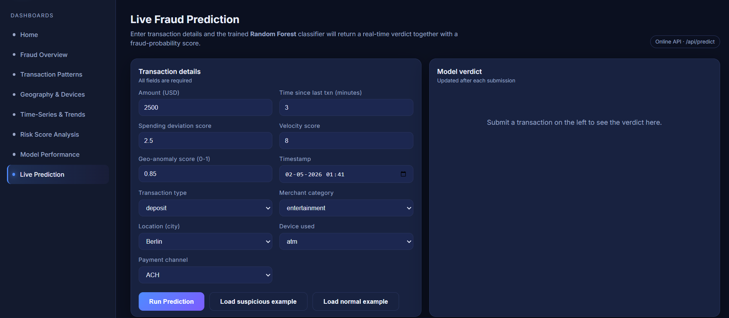
Figure 39: Aggregations data view returned by the structured data endpoint
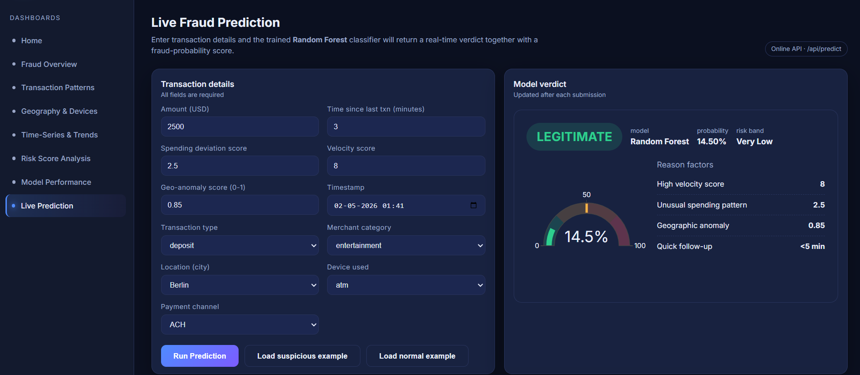
Figure 40: Reference relational schema visualised as an entity-relationship diagram
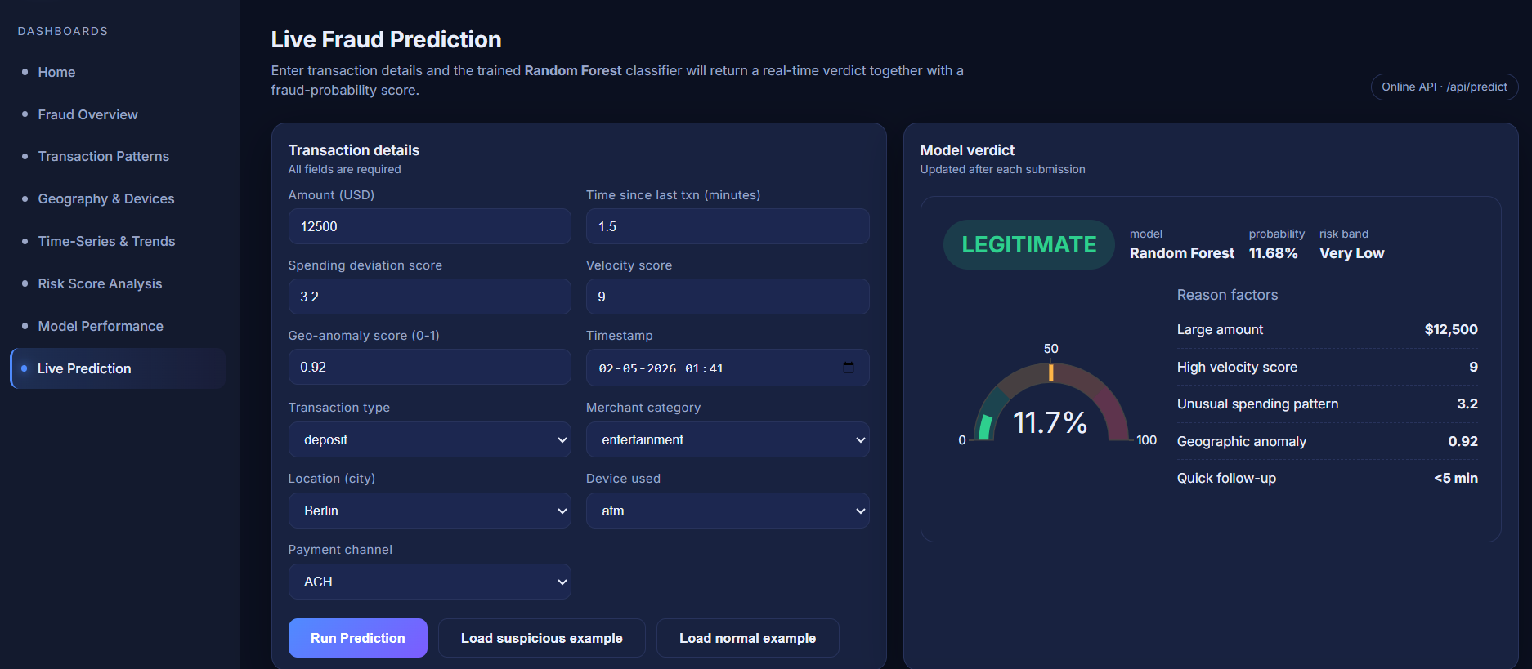
Figure 41: Notebook exploratory-analysis snapshot inside the analytical environment
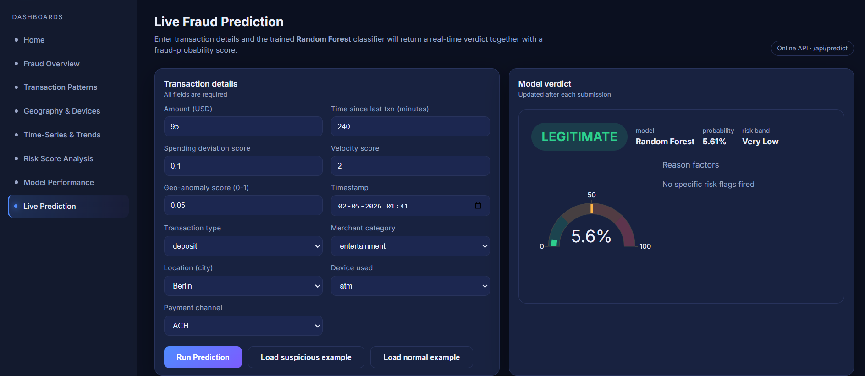
Figure 42: Notebook model-evaluation snapshot showing the metric tables

